Web CMS
2006

NETWORKING TECHNOLOGY (THAILAND) COMPANY LIMITED
Index
1 Introduction of Web CMS 2006 1
2 Begin to use Web CMS 3
2.1 System requirements 3
2.2 Begin 3
2.3 Fill in the information of registration 3
2.4 Enter users’ back 4
3 Manage functions of sharing 6
3.1 Logo 6
3.2 Member manager 9
3.3 Files manager 11
3.4 Analyze flux 13
3.5 Link manager 15
3.6 E-mail to be sent 17
3.7 Simplified Chinese to Traditional Chinese 17
3.8 Traditional Chinese to Simplified Chinese 18
4 Design website cover 19
4.1 Set cover style 19
4.2 Set model background 20
4.3 Set count style 21
4.4 Set the copyright 22
4.5 Set language bar 23
4.6 Set website logo 25
4.7 Pop window 25
4.8 Set Javescript effect 26
4.9 Self cover 27
5 Set Multiple Language 29
6 Website management 30
6.1 Item manager 30
6.2 Add new item 31
6.3 Modify item 33
6.4 Arrange item 33
6.5 Item settings 34
6.6 News 36
6.7 Set copyright 36
6.8 Set count style 37
6.9 Member zone 38
6.10 Set Banner 40
6.11 Set pop window 41
6.12 Set addons 42
6.13 Link manager 43
6.14 Set Javascript effect 44
6.15 Set model style 45
6.16 Set model background 47
6.17 Set top background 48
6.18 Set language bar 49
6.19 Set menu style 50
7 Item manager 52
7.1 Single page 52
7.2 Independent page 54
7.3 News 56
7.4 Pictures 67
7.5 Feedback manager 77
7.6 Guestbook manager 83
7.7 Trade 85
7.8 Want ad 94
7.9 Download 102
7.10 Shopping 110
7.11 Self form 119
8 Introduction of on-line HTML 122
8.1 Add a table 123
8.2 Insert image 124
8.3 Insert flash 127
8.4 Insert windows/real media. 128

Introduction of Web CMS 2006
Congratulate to select web CMS! Because it is a build site system which has the most powerful components, the most templates and the most abundant language categories in the world at present. You can build and manage your own website conveniently as long as you can type!
- Ten thousands of templates, hundreds of website cover and dynamic menu styles selected by you at random!
- Front and back of Web CMS 2006 support 12 kinds of languages, such as Simplified Chinese, Traditional Chinese, English, French, German, Russian, Japanese, Korean, Spanish, Portuguese, Italian, etc.
- The on-line HTML editor which has powerful functions supporting character, picture, flash and video mixed arranged.
- The multilevel items which can be added, deleted, modified and arranged at random. And you can hide the items and change visiting permission of user groups.
- Equipped with multiform function modules, such as, single page, independent page, self link, news, pictures, feedback, guestbook, download, want ad, trade, shopping, self-form, etc.
- Convert item content to Javascript code using Create Code and put the code into the position needed, which can achieve dynamic update.
- You can select and design the style of templates. Items for selected include model style, model color, menu style, copyright, friendly link, Banner ad, count, member zone, language bar, template background, top background, news, pop window, addons, Javascript effect, etc.
- Equipped with the share functions which include member manager, files manager, analyze flux, logo, link manager, email to be sent, Traditional Chinese to Simplified Chinese. Simplified Chinese to Traditional Chinese, etc.
- The style of cover can be customized or uploaded directly.
- User management equipped with scores and item visiting permission are integrated perfectly.
The new features of web CMS 2006:
New feature 1: 12 kinds of languages
New feature 2: 21600 templates
New feature 3: Single page
New feature 4: Independently page
New feature 5: News
New feature 6: Pictures
New feature 7: Feedback
New feature 8: Guestbook
New feature 9: Trade
New feature 10: Want Ad
New feature 11: Files download
New feature 12: On-line shopping
New feature 13: Self form
New feature 14: Analyse flux
New feature 15: E-mail to be sent
New feature 16: Javascript effect

New feature 17: News comment

New feature 18: Reply message

New feature 19: Identify language automatically

New feature 20: Trade order

Begin to use Web CMS

System requirements
This system requires internet explore 5. 5 or higher. The website generated by this system may be browsed in all internet browsers.

Begin
Clicking new user registration and enter the interface shown below.
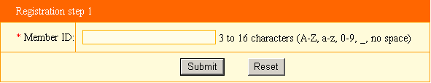
User name is comprised of letter, number or underline, length 3-16 bytes. After input user name, system will examine whether the user name existed automatically, you need input a new one if it existed.
Next step - fill the information of registration

Fill in the information of registration

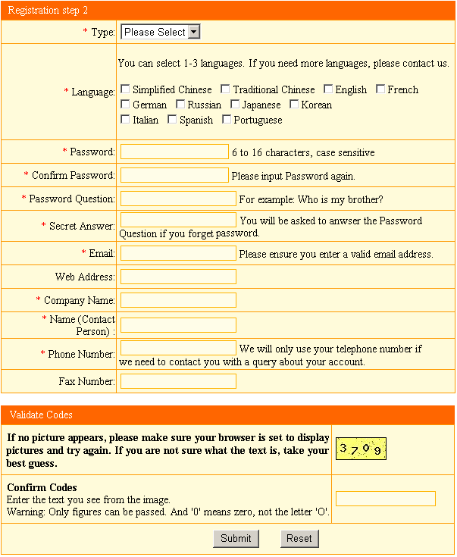
Next step - enter users’ back after successful registration

Enter users’ back
After fill the information of registration, click “submit”, enter users’ back directly. 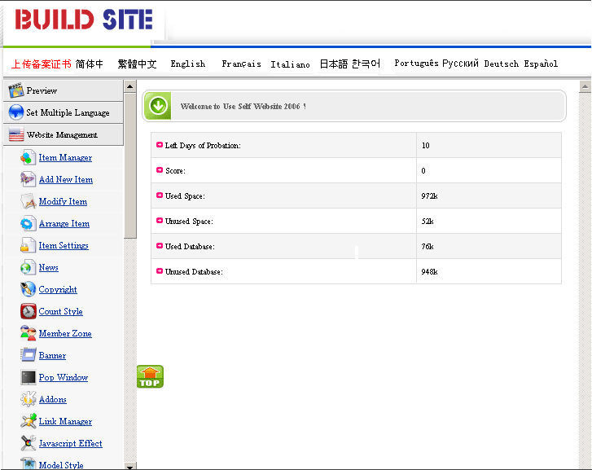

Manage functions of sharing
It sets the global parts of sites for all the languages and avoids reduplicate work in the process of making website.

Logo
Manage functions of sharing - Logo
Path: Manage menu in the left side of back “Manage functions of sharing”→ “Set website logo”
The page layout is shown below after clicking edit section.

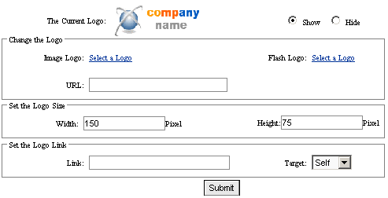

Current website logo: website or company logo; you may set it display or not.

Modify website logo: input logo address, select image or flash logo.

Upload image or flash: After clicking “select website logo”, a popped dialog box shown below, which include 3 options: upload image or flash, select a image or flash from library and web image or flash.

Upload image from local computers.

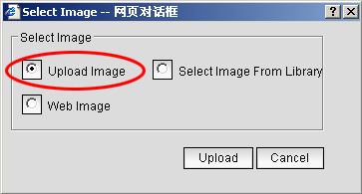

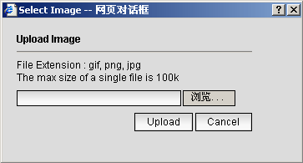

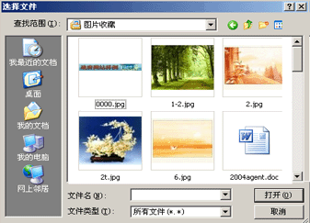

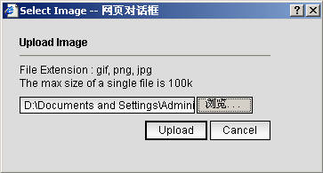

------------------------------------------------------------------------------------------------------------------
Select image from library

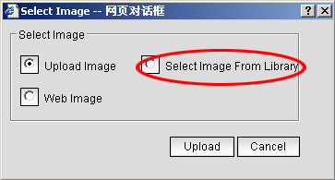

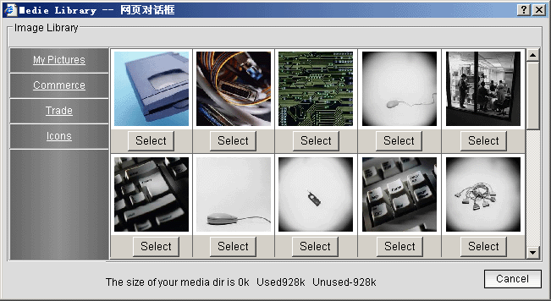

-----------------------------------------------------------------------------------------------------------------
Web image: input the URL of image, then submit

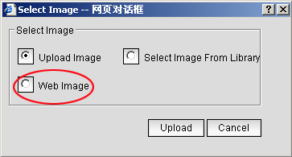

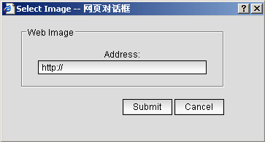
Examine the attribute of image by clicking the right key of mouse, input the URL directly.
Set the logo size: set up the width and height of website logo. The whole size of page layout should suit to the trim size of logo to avoid influencing the overall effect. Otherwise, it will make logo stretch or twist.

Set logo link: Set the URL when click “web logo”, it may also set whether pop a new window.

Member manager
Manage functions of sharing - member manager
Path: Manage menu in left side of back “Manage functions of sharing”→“Member manager”
Click “Member manager”, editing section shown below.

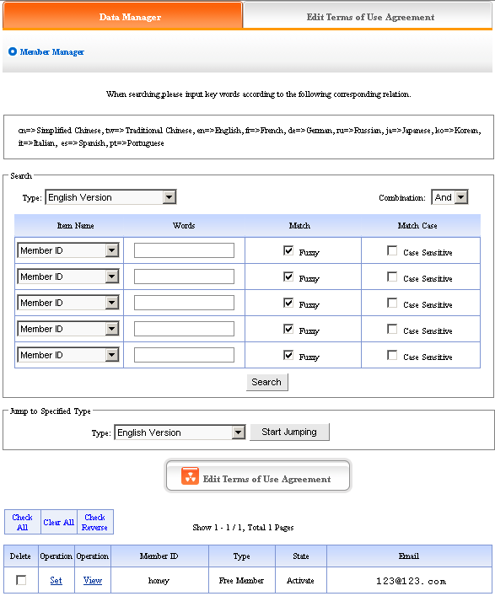

According to items provided by “Search category”, “Field name”, input keywords in “Search content”, search user information. The member information which registered in your website may displayed in the interface shown below, you may set user, examine user information, on-line sending e-mail to users.
Edit terms of use agreement: the editing content is the agreement which seen when member register.
Click “Edit terms of use agreement”, pop the text field shown below, and edit the agreement of member registration here.
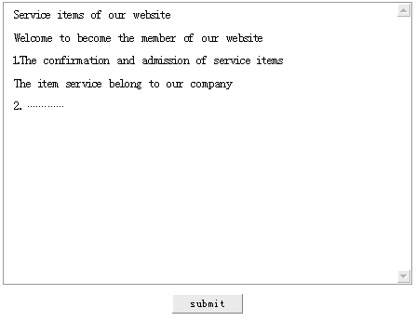
Set: Click “set” which is under “edit terms of use agreement”, you may set users level, state, score, etc.
Examine: Click “examine” which is under “edit terms of use agreement”, you may examine the information data of registered members.
E-mail box: Click “users’ e-mail box address” which is under “edit terms of use agreement”, you may on-line sending email to users by senior editing style.
Powerful searching function make you lookup users conveniently, you may search the information of any user, achieve the most fashionable assembled searching.

Files manager
Manage functions of sharing - Files manager
Path: Manage menu in the left side of back “Manage functions of sharing”→“Files manager”
Click “Files manager”, editing section shown below.

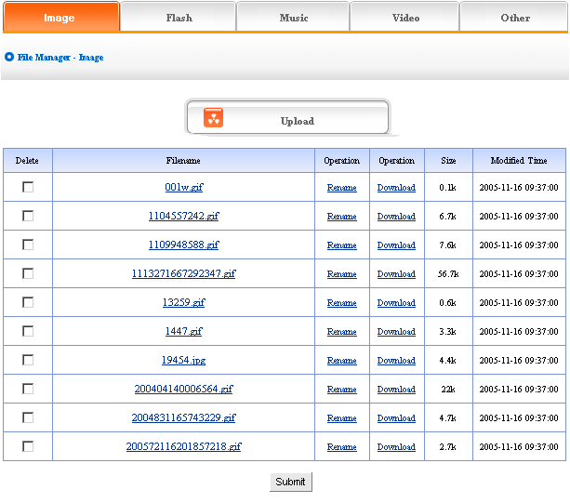

Click “others”, you may upload files which have 80 file extensions: ace, acp, ani, arj, art, au, avi, bmp, bz2, cab, cda, cgm, chm, css, cur, dcx, dib, doc, dtd, gif, gzip, htm, html, ico, iso, jar, jfif, jif, jpe, jpeg, jpg, js, la1, lqt, lzh, m1v, m2v, m3u, m4e, mid, midi, mnd, mp1, mp2, mp3, mp4, mpa, mpe, mpeg, mpg, mpga, mps, mpv, pcd, pcx, pdf, png, psd, ra, rar, rle, rm, rmi, rtf, ssm, swf, tar, tif, ttc, ttf, txt, uue, vpg, wav, wma, wmf, wrl, xml, xsl and zip.

Click “upload files”, 5 files may be uploaded at the same time.
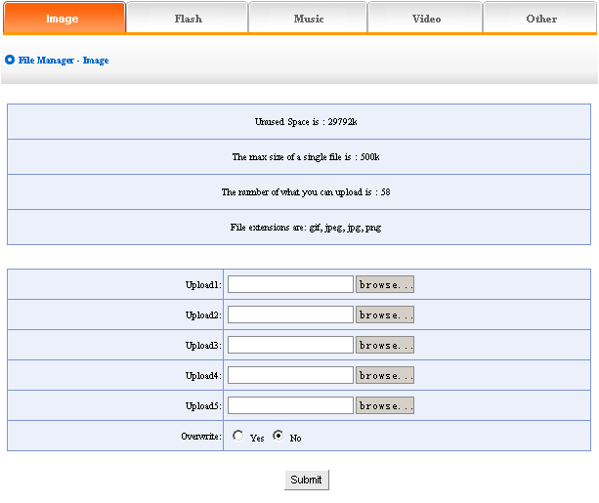

Analyze flux
Manage functions of sharing - analyze flux
Analyze flux has the statistic function of visiting quantity, the statistic of visiting quantity is by the period of time, set the number of count in the total visiting quantity by yourself, not only audio-visual but also convenient.

Path: Manger menu in the left side of back “Manager Functions of Sharing”→“Analyze flux”
Click “Analyze flux”, page layout of editing section shown below.
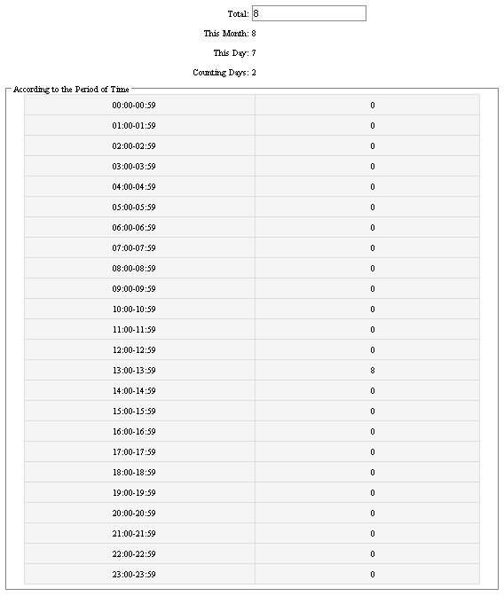
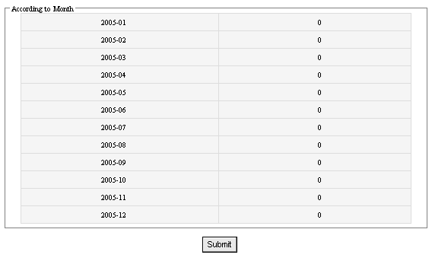

Link manager
Manage functions of sharing - Link manager
Friendly link is the area where websites exchange link. Add link here, the other site’s friendly link will appear in the generated page (The image below shows the friendly link with sina). The “Friendly link” of this system may be character link and also picture link.
Path: Manage menu in the left side of back “Manage functions of sharing”→“Friendly link manager”.
Click “Friendly link manager”, edit section page layout shown below.
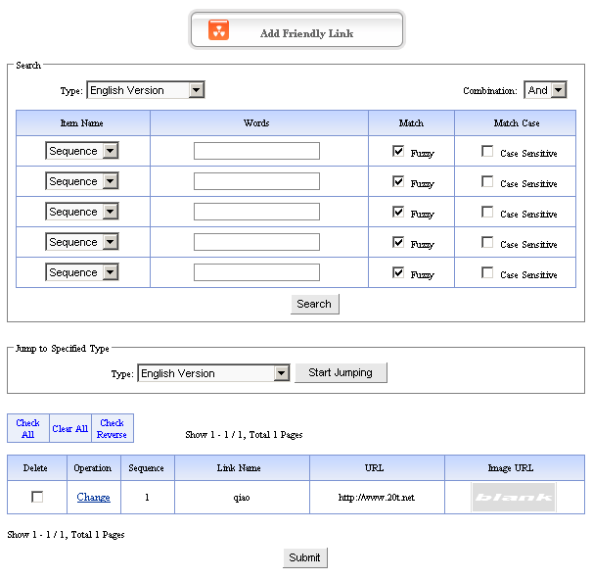
Click “Add friendly link” page switch to the image below.
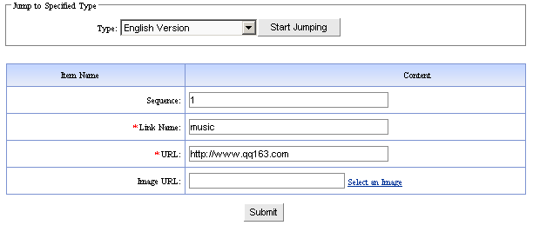
Sequence: it is the number which is used to arrange order of friendly link.
Title of link: The name of friendly site.
The address of link: the URL of website which want to link.
The image address of link: the URL of image which want to link. Click “select image” upload image of friendly link.

E-mail to be sent
Manage functions of sharing - E-mail to be sent
This item set the default e-mail box and signature of addresser (your esteemed company).
Path: Mange menu in the left side of back “Manage functions of sharing”→“E-mail to be sent ”.
Click “E-mail to be sent”, the edit is section shown below.
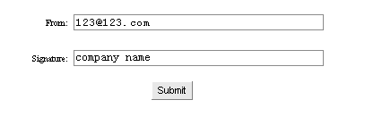

Simplified Chinese to Traditional Chinese
Manage functions of sharing - Simplified Chinese to Traditional Chinese
In order to convenient for you to switch language when editing website, system set this function to switch language, put the character which need switched in the text field, click “Simplified to Traditional” the Simplified will switch to Traditional.
Path: Manage menu in the left side of back “Manage functions of sharing”→“Simplified Chinese to Traditional Chinese”.

Click “Simplified Chinese to Traditional Chinese”, page layout of editing section shown below.
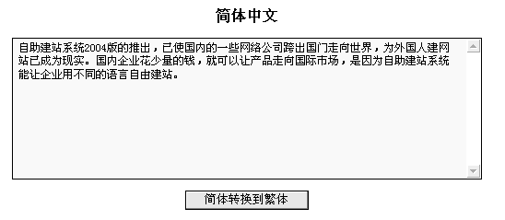
Shown below after switch:
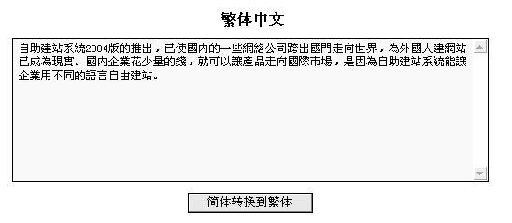

Traditional Chinese to Simplified Chinese
Manage functions of sharing - Traditional Chinese to Simplified Chinese
Path: Manage menu in the left side of back “Manage functions of sharing”→“Traditional Chinese to Simplified Chinese”
Click “Traditional to Simplified”, page layout of editing section is shown below.
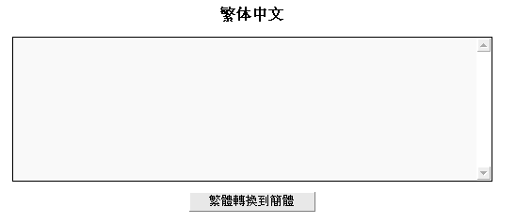
The step of “Traditional Chinese to Simplified Chinese” is the same as above.

Design website cover
In order to beautify your website, this system add the function of website cover, you may set cover style, background, etc. it possess convenient and shortcut operation and artistic effect.

Set cover style
Design website cover - Set cover style
Path: Manage menu in the left side of back “Design website cover” →“Set cover style”
Click “Set cover style”, back is shown below.
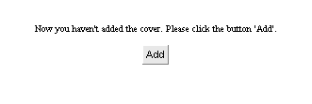
Default cover is closed, so we need click to open cover. Back will hint open cover successfully.
After open cover successfully, click “set cover style”, back shown below:
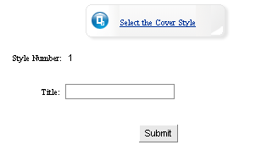
In the dialog box, “Title of window” is the name of title bar when preview website cover.

After fill in, click “select cover style” button, use the appropriate cover templates. Back is shown below.

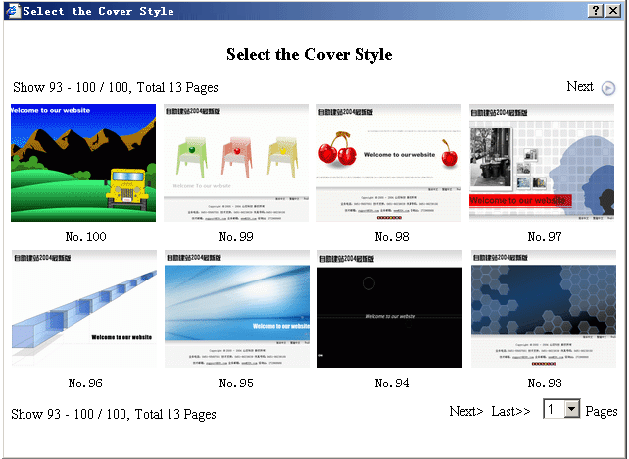

After select and click thumbnail, the page shown below:

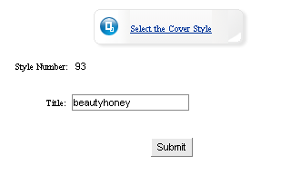

Click “submit” button, set “Cover style” successfully.

Set model background
Design website cover - Set model background
Path: Manage menu in the left side of background “Design website cover” →“Set model background”
Click “Set model background”, page layout of back shown below.
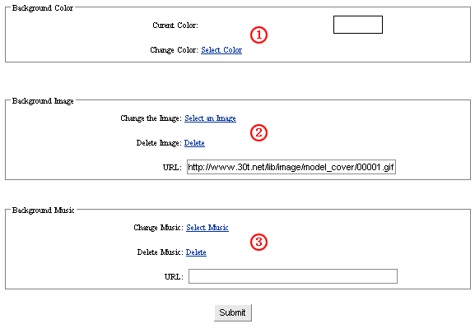
- Set background color: Click “select color”, pop palette, select the background color of cover page
- Set background image: Click “select image”, scan background image of cover page, or put into the URL of image. (note: if select background image,the background color cant display)
- Set background music: Click “select music” select the background music of cover page,or put into the URL of music

The 3 functions above, make cover page vividly.

Set count style
Design website cover - Set count style
Count, it is the counting function, which makes you know the clicking rate of your website.
Path: Manage menu in the left side of back “Design website cover” →“Set count style”.
Click “Set count style”, page layout of back is shown below.
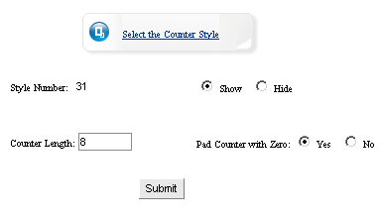

Number length: it means the digit of counter displayed in the cover, which is usually 8.

Add “0” before it: it means when clicking rate less than 8 digits. Counter display whether put “0” occupied. We usually select “Yes”.

If you needn’t counter, select “hide” in the page above, counter will not be displayed in the website.

Click “Select counter style” select the counter style which you like, pop the dialog box shown below.

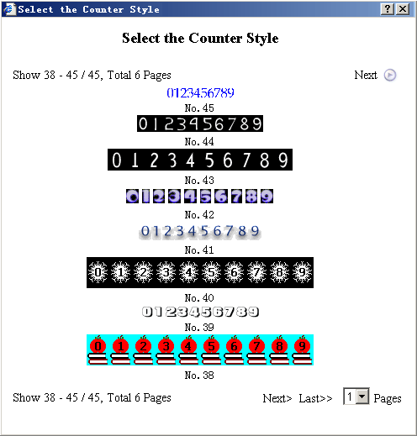

It will return to the above page layout after select, select “submit” button, set “count style” successfully.

Set the copyright
Design website cover - Set the copyright
You may not only fill in copyright here, but also input content or insert code according to personal habit.
Path: Manage menu in the left side of back “Design website cover”→“Set the copyright”
Click “Set the copyright”, page layout of back is shown below.
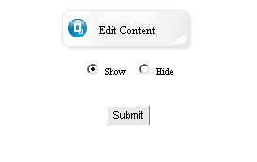
You may set whether display copyright. Click “edit content”. In the back, we enter into the following image shows.
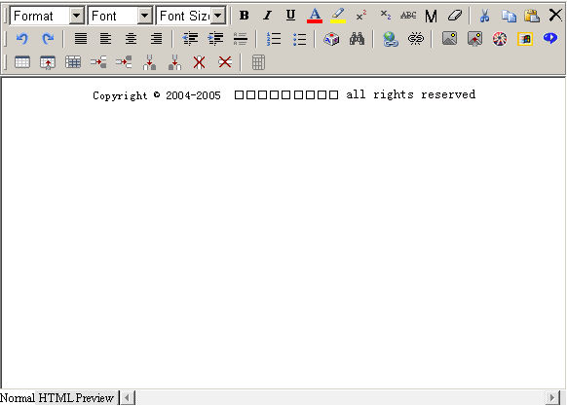
You may not only fill in copyright, but also input any content (image/other files)or insert code according to personal habit

Set language bar
Design website cover - Set language bar
Language bar is the selection button of multiple languages in cover page.
Path: Manage menu in the left side of back “Design website cover” →“Set language bar”
Click “Set language bar”, back shown below.
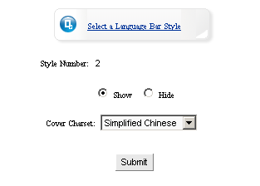
Cover language coding means the char set of the cover. For example, the char set of the cover is English. Then the language of website cover is English.

Click “Select language bar style”, pop the dialog box shown below, select the appropriate language bar style for the templates. You may also set whether display language bar.

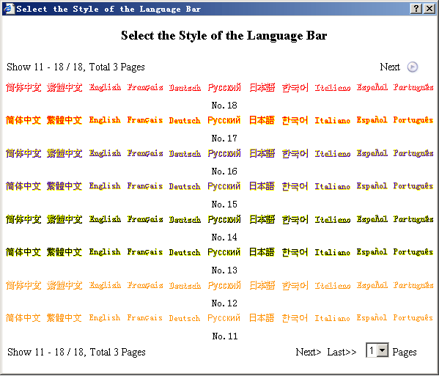

Select appropriate language bar in the dialog box, return to the upper level directly, click “submit”, set language bar successfully.

Set website logo
Design website cover - Set website logo
Set website logo means change original logo of cover page (resemble as the website logo, the same operation step. The difference is website logo displayed in each page, the logo of cover page only displayed in cover page).
Path: Manage menu in the left side of back “Design website cover” →“Set website logo”
Click “Set website logo”, page layout of back shown below.
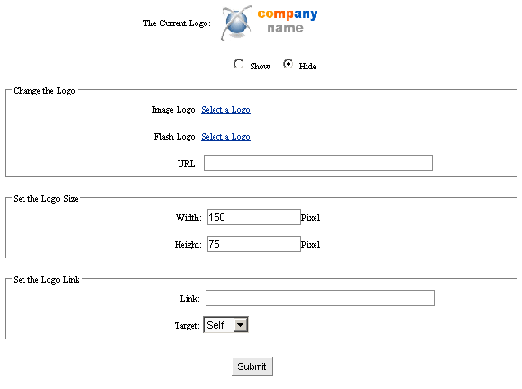
The content of image above is the same with the operation step of “set website logo”. for more details see page6－7.

Pop window
Design website cover - Pop window
Set the size, the content and the title of the window in the cover page. You can show news or advertisement commonly by it.
Path: Manage menu in the left side of back “Design website cover” →“Set pop widow”
Click “Pop window”, the page layout of back shown below.
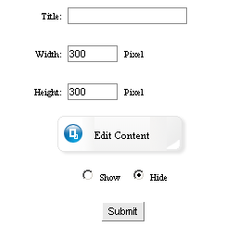

The title of window: it means the title of pop window when preview cover page.
Width and height: The size of pop window in the cover page.
Click “Edit content” button, the back pop the editing area shown below. If you need not the pop window in the cover page, you can select “hide” under the “edit content”.

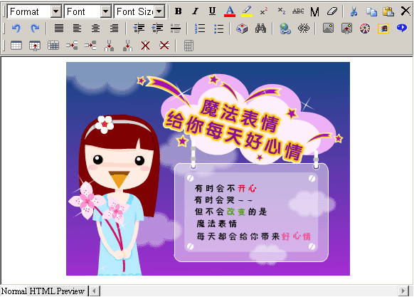

You can input any content or insert code in the editing area according to your personal habit or company needs. Such as news or advertisement, click “submit” after edit, set “pop window” successfully (note: be sure select “display” in “set pop window”, because the system default hide state).

Set Javescript effect
Design website cover - Set Javascript effect
Set Javascript effect: it means set the special effect of cover page, such as: fluttering image, followed by the mouse etc.
Path: Manage menu in the left side of back “Design website cover”→“Set Javascript effect”
Click “Set Javascript effect”, the page layout of back shown below:
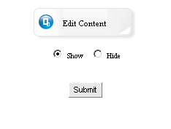

Click“Edit content”,enter into the editing window shown below:
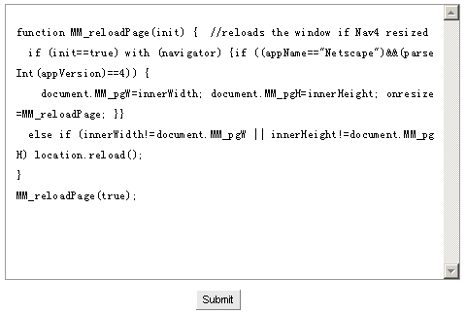
The special effect of webpage which we edit are always some effects that usually use, such as floating images, color changed background, followed by the mouse etc. You may copy the effects code to the editing area directly, click “submit” after that, set Javascript effect successfully

Self cover
Design website cover - Self cover
Self cover means design website cover by yourself
Path: Manage menu in the left side of back “Design website cover” →“Self cover”
Click “Self cover”, the page layout of back shown below.
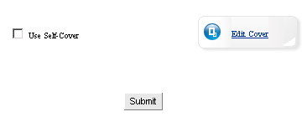

Click “Edit content”, enter into the page shown below, you may not only upload “self cover” and relative images,media files, but also the images in the library, media files etc which have been uploaded.

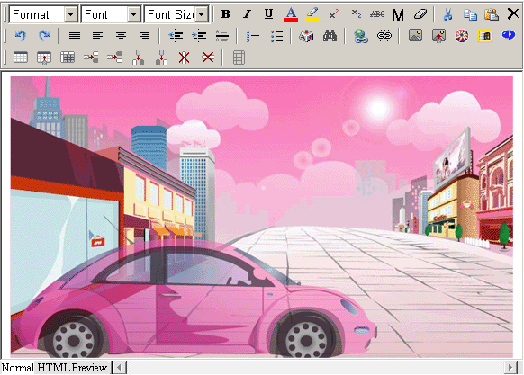

(note: be sure select “Self cover”, otherwise the it wont display)

Set Multiple Language
Set multiple language may set the language which you need and the default language of the homepage
Path: Manage menu in the left side of back→“Set multiple language”

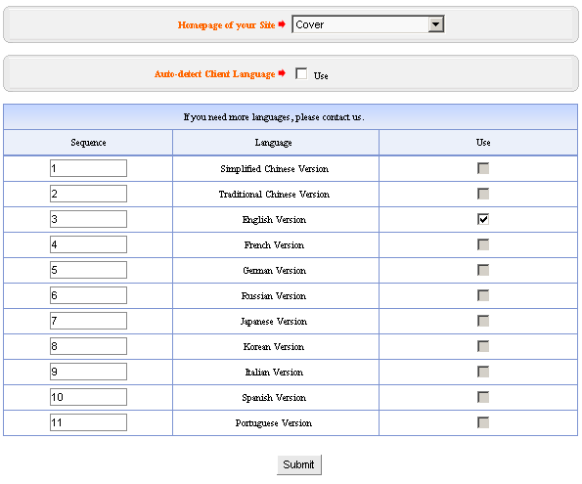
Set homepage: Set the first page of website, select “cover” in the drop-down list. Then the cover will be the first page. If we select language style, the first page will be that language. Such as we select Simplified Chinese in the drop-down list, the first page of website will be Simplified Chinese after submit. If we select English, then the first page we open the website will be English after submit, it is convenient for the users to edit language.
Identify client language automatically: Just as its name imply, it is more intellectualized function, it may change by the change of client language, convenient for the users who use the different languages.
Sequence of display: Sequence of each language arranged in language bar, arranged by the number, set the order of Simplified Chinese, Traditional Chinese, English, French, German etc.
Open: Set the language which you need open in the check box, you may open 11 languages most at the same time, one language least.

Website management

Item manager
Website management - item manager
Item manager means add and modify the item name, show or not, target, level, delete item etc.
Path: Manage menu in the left side of back “Website management” →“Item manager”
Click “Item manager”, page layout of back shown below.

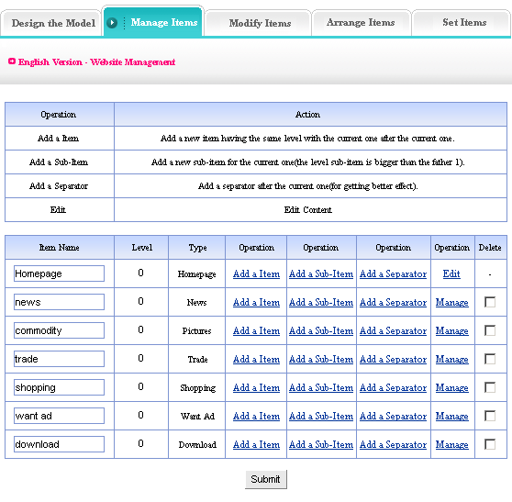
We elaborate practical meaning and functions of each item in the image above:
- Item name: the title of each item (you may modify directly here).
- Item level: the level shown in dynamic menu(level “0”,shown in menu bar directly,level “1”,shown in the branch of menu bar, level “2”,shown in the branch of level 1.
- Add new item: Add a new item which has the same level with the current one after the current one.
- Add a sub-item: Add a new item for the current one (the level sub-item is bigger than the father 1).
- Add a separator: Add a separator after the current one.
- Edit /Manage: In the seventh item, click “edit” or “manage”, you may edit or manage this item.
- Delete item: Select in the check box of the last item, click “submit” delete this item.

Add new item
Website management - Add new item
Add new item means newly-built item, item types are corresponding with function management.
Path: Manage menu in the left side of back “Website management”→“Add new item”
Click “Add new item”, page layout of back shown below:
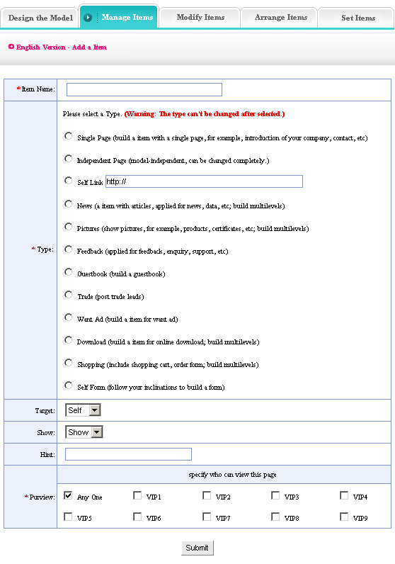
We elaborate actual meaning and function of each item in the image above:
Item name: it means the name of newly-built item, it will be shown in the menu bar of webpage, it is the “homepage”, “hot news” ……in the “item manager” after submit.
Item type: it means the type of newly-built item, the operation is to select a function in the item types of image above as this item type.
Target: Set whether the item open in the original window. There are two options in the drop-down list: “self” and “blank”, that means the newly-build item switch from the original window or pop a new window when preview.
Show: Set whether the newly-built item show in the menu bar of webpage. If we select “hide”, the item will not be shown in the menu bar when preview the website.
Hint: The introduction of item when preview webpage and putting the mouse on the item character
Purview: The permission when visitor visit the item
When all the above content is completed, click “submit”. Then add new item successfully.
We elaborate the actual meaning and functions of each item in the image above:
- Single page:
Build an item with a single page; for example, introduction of your company, contact, etc.

- Independent page:
Model-independent, can be changed completely.

- Self-link:
Set the link which arrive at other URL, enter into appointed URL after click.

- News:
A item with articles, applied for news, data, etc; build multilevels.

- Pictures:
Show images, for example, products, certificats, etc; build multilevels.

- Feedback:
Applied for feedback, enquiry, support, complain, etc.

- Guestbook:
Build a guestbook.

- Trade:
Post trade leads.

- Want ad:
Build a item for want ad.

- Download:
Build a item for online download, for example, software, download files.

- Shopping:
Include shopping cart, order form, and build multilevels.

- Self form:
Follow your inclinations to build a form.

Modify item
Website management - Modify item
Modify item means modify item name, set show or not, target, add hint, etc.
In the process of designing website, website maker may change original setting according to actual situation.
Path: Manage menu in the left side of back “Website management“→ “Modify Item “
Click “Modify item“, page layout of back shown below:
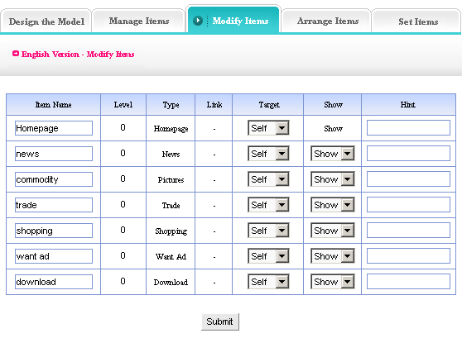
All the options in the image above are all set in “Add new item“ originally, such as “item name“, “target“, “show“, “hint“ etc, can be changed(note: we should emphasize that the item type which we select in “add new item “cant be changed)

Arrange item
Website management - Arrange item
It means set the sequence of item, click “arrow“ to set sequence
The word “level“ mentioned in the “Item manager“ is arranged in different grade items. The “sequence“ is arranged in the same grade items.
Path: Manage menu in the left side of back “Website management “→ “Arrange item “
Click “Arrange item “, page layout of back shown below:
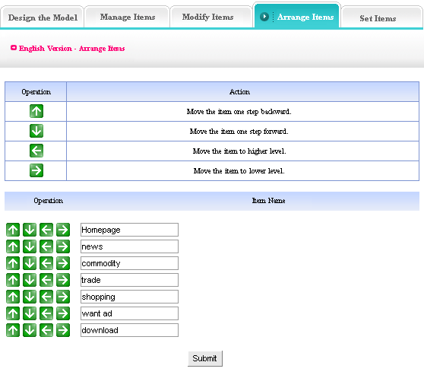
See the operation and function of “arrow“ in the form above.

Item settings
Website management - Item settings
It means set sort, per row count, width and height of thumbnail, purview, etc.
Path: Manage menu in the left side of back “Website management “→ “Item settings “
Click “Item settings “, page layout of back shown below.
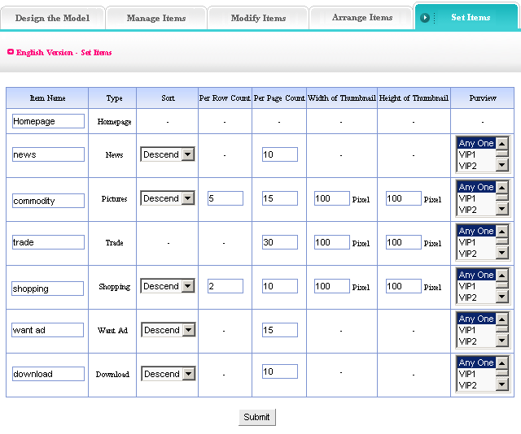
We elaborate the meaning and function of each item in image above:

Sort: it is different from the sequence in “arrange item“, the sequence means the order of items shown. the sort commonly means the item type, such as “News“, “Images“, “Feedback“, “Guestbook“, “Want ad“, “Download“, “Shopping“, “Self form“, the content is not be added at the same time, so we may select sort here. It includes “Ascend“, “Descend“, and “Self“. That mainly depends on the sequence number we filled in when we add content.

Per row count: That is in “Images“ and “Shopping“ two items, the number of images displayed in per row. You may set according to different need and habit.

Per page count: Set content of “News“, “Page“, “Guestbook“, “Trade“, “Want ad“, “Download“, “Shopping“, “Self form“ shown in each page. Adjust it according to your different need and artistic website.

Width and height of thumbnail: the function is to define the thumbnail which need uploaded in “Images“, “Trade“, “Shopping“. Set it according to the integrated structure and artistic of webpage.

Purview: Set the authority of visitors.
All the options completed, click “submit “, set item settings successfully.

News
Website management - Set news
It means set the up to date content of website, display in the certain position (left column or the right column)after setting, you may also input the other content, modify the title of item.
Path: Manage menu in the left side of back “Website management “→“Set news “
Click “Set news “, page layout of back shown below:
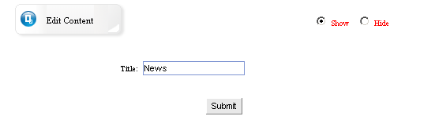
Fill in title: The title filled in is the main title displayed in the “news “area.

click “Edit content “, enter into the editing area shown below, you may not only edit news, but also fill in the other contents which noticeable, such as, “hot news “, “news published “(shown above, if you want to set news, you must select “show “, otherwise the edited content wont be shown in the website)
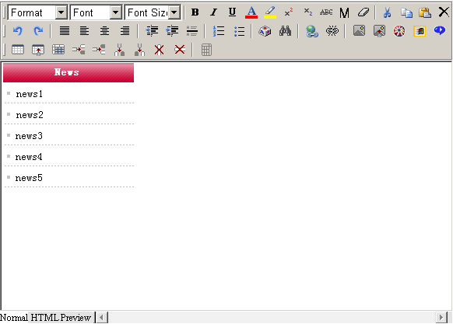
After editing the content of “news “, click “submit “, set “news “successfully.

Set copyright
Website management - Set copyright
Copyright is at the bottom of webpage. You may not only fill in copyright, but also input any content or insert code according to personal habit.
path: Manage menu in the left side of back “Website management“→“Set copyright “
Click “Set copyright“, page layout of back shown below.
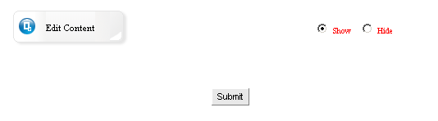
Click “Edit content “edit copyright, you may set whether display copyright. The operation of setting copyright is the same with setting news of cover page. For more details see page 21.

Set count style
Website management - Set count style
Path: Manage menu in the left side of back “Website management “→“Set count style“
Click “Set count style“, page layout of back shown below.
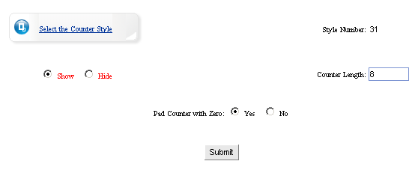
Count length: the count digit shown in cover page, which is usually 8 digits.

Pad counter with “0 “: Whether counter display “0 “occupy position when clicking rate less than 8 digits. We usually select “Yes “.

If you don’t need counter, you should select “hide “in the image above, then the counter will not be displayed in website

click “select counter style “select the counter style which you like, pop the dialog box shown below:

After select, select “submit “, set count style successfully.

Member zone
Website management - Member zone
Path: Manage menu in the left side of back “Website management“→ “Member zone“
Click “Member zone“, page layout of editing area shown below:

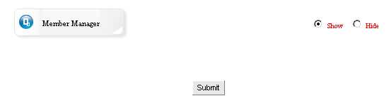

The “Member zone“ is identical with the front “Member zone“ in “Manage the functions of sharing“, the difference is the “Member zone“ which in “website management“ isn’t enter into editing page directly, when enter into the page shown above, you may select whether hide “Member zone“. In order to beautify website, here we set the suppressible function.
You may input the keywords which need to search in “words“ according to item provided in drop-down list of “category“, “item name“, search users information
The member information which registered in your website may is shown in the page below, you may set users; examine users information, on-line sent e-mail to users.
Terms of use agreement: Click “Edit terms of use agreement“, pop the text field shown below, you may edit the terms of use agreement here.
Click “edit terms of use agreement“, pop the text field, input the terms of use agreement here.
Set: Click “set “in the form which under “edit terms of use agreement “, you may set the level, state, integral of users in this page
Check: Click “check “in the form which under “edit terms of use agreement “, you may check the information data of registered members.
Email: Click the email address in the form under “edit terms of use agreement “, you may on-line send email to users through senior edit mode.
Powerful searching function is convenient for you to lookup users; you may search any user’s information and achieve the most fashionable assembled search.

Set Banner
Website management - Set Banner ad
Set Banner ad is the ad bar in the upper of webpage, it is commonly image poster of company or ad, you may set whether display.
Path: Manage menu in the left side of back “Website management “→“Member manager“
Click “Member manager“, page layout of editing area shown below.
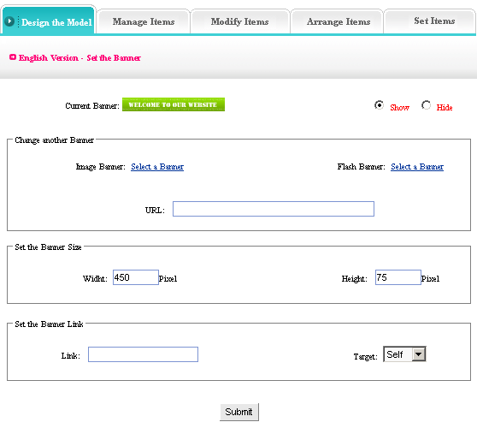
Change banner: you may upload image or Flash ad, also use the web ad.
Set banner size: set the height and width of banner displayed in the upper of website.
Set banner link: arrive at the URL of linked after clicking ad, set whether open in original window.
After complete the options above, click “submit “, set Banner ad successfully.

Set pop window
Website management—Set pop window
Set pop window means set pop window or not, the size and the title of the window, edit window content
Path: Manage menu in the left side of back “Website management “→“Set pop window“
Click “Set pop window“, page layout of back shown below.
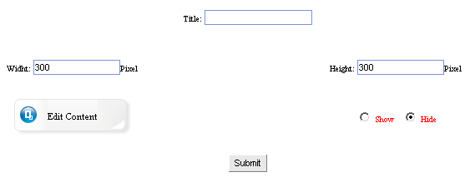

Title: the title of window when open website
Height / width: the size of window
Click “edit content “pop the window shown below, edit the content displayed in “pop window “.

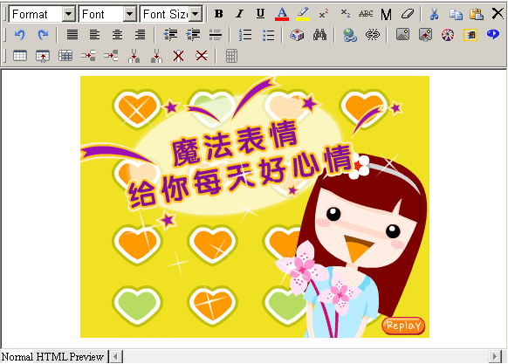
The “pop window “usually set as ad or bulletin because of the conspicuous position in the website editing, if you don’t need the pop window in website, you should select “hide “.

Set addons
Website management - Set addons
It means set the content of top right corner in website, default “display time “.
Path: Manage menu in the left side of back “Website management “→“Set addons “
Click “Set addons “, page layout of back shown below:
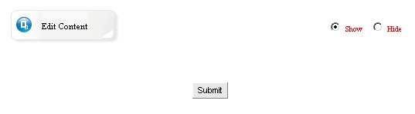
Click “Edit content “, enter into the page shown below: content default “display time “.
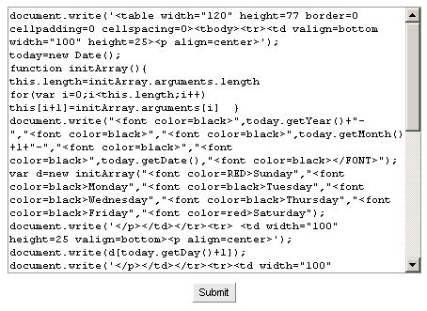
Here default is display time, you may change into other code according to your own habit, for example, weather forecast, constellation hint etc.

Link manager
Website management - Link manager
Link manager is websites exchange link. “Friendly link “is character link or image link. And you may select the arrange mode of friendly link, set the quantity of friendly link.
Path: Manage menu in the left side of back “Website management “→“Link manager“
Click “Link manager “, page layout of back shown below.
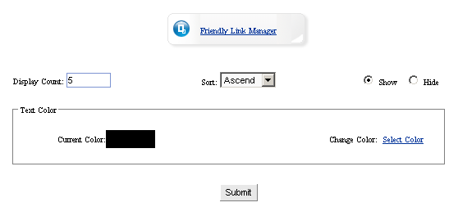
Display count: you may set the count of friendly link displayed in website
Sort: the sequence of friendly link displayed in webpage, include ascend and descend (sorting depend on the sequence number filled in when adding friendly link)
Set whether display “friendly link “
Text color: set text color displayed when link, default color as black

Set Javascript effect
Website management - Set Javascript effect
Set Javascript effect means set webpage effect, such as fluttering images, followed by mouse, changed color background, etc
Path: Manage menu in the left side of back “Website management “→“Set Javascript effect “
Click “Set Javascript effect “, page layout of back shown below:
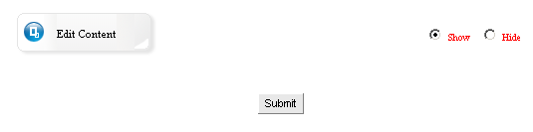

Click “Edit content “pop the editing area shown below:
You may input code of Javascript effect in the editing area, if you don’t need the effect in your website, select “hide “ in the image shown above

Set model style
Website management - Set model style
This system provides 100 kinds of webpage modes, 216 kinds of website color for users.
Path: Manage menu in the left side of back “Website management “→“Set model style “
Click “Set model style “, page layout of back shown below:
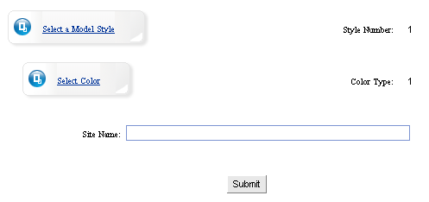
Click “select a model style“ select the model style of each element arranged, that is integrated model of website(include position arranged manner of “Member zone“, “Friendly link“, “Language bar“, “News“, etc )
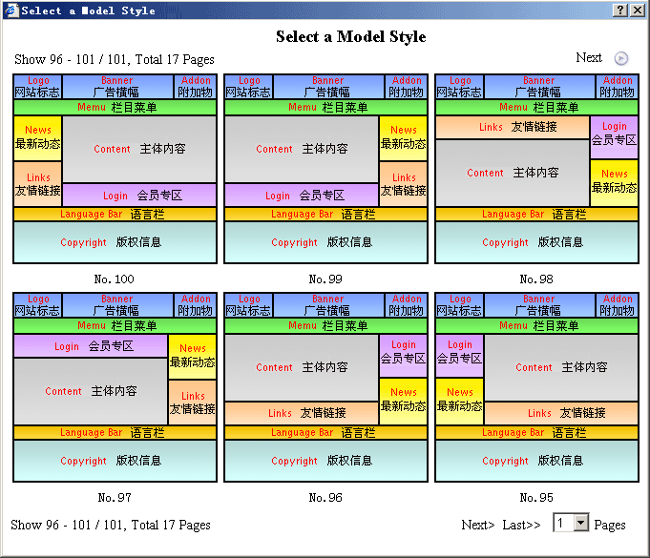
Select a model in the above model styles, return to the front-class page.
Click “select color “, pop the dialog box shown below, and select the model color here.
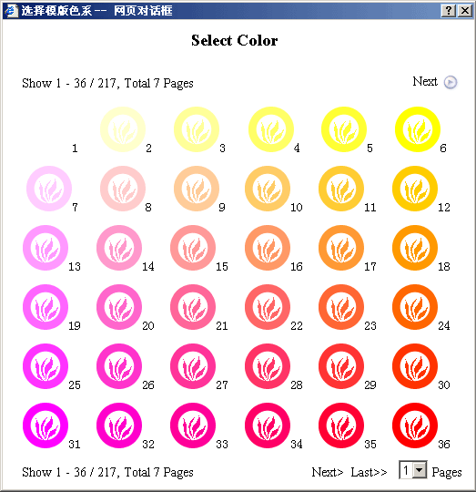

The color selected here is the collectivity color of website frame, means the title bar color of “News “, “Friendly link“, “Member zone“, “Language bar“, etc.

Set model background
Website management - Set model background
You may modify background color, upload background image, upload background music in “Set model background“.
Path: Manage menu in the left side of back “Website management “→“Set model background “
Click “Set model background “, page layout of back shown below:
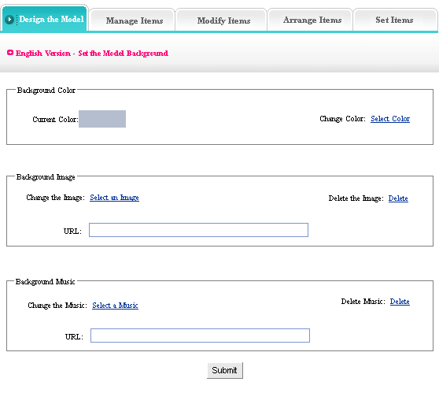
Background color: the background color of website (each webpage)
Background image: the background image of website (each webpage) if you don’t need background image, clicks “Delete background image “(note: if set background color and image at the same time, background image displayed, but background color hide)

Background music: the background music is the music of homepage, but not display in each page. (if you want background music in each page, you should insert music code in “Copy right “)

Set top background
Website management - Set top background
It means set the top background of website(Logo, Banner area, above menu bar), color or image
Path: Manage menu in the left side of back “Website management “→“Set top background “
Click “Set top background “, page layout of back shown below:
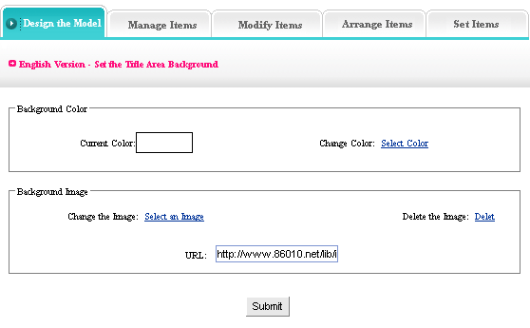
The setting method of “Top background“ is identical with “Set model background “for more details see page 19.

Set language bar
Website management - Set language bar
This system support 11 kinds of languages, language bar is the area where select language edition in website. Here, the language bar setting is different from the front, the difference is the former one set language bar of cover page, but here set language bar of website, the same operation
Path: Manage menu in the left side of back “Website management “→“set language bar “
Click “Set language bar “, page layout of back shown below:
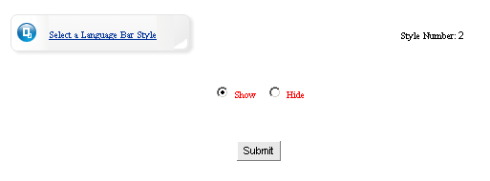
Click “Select a language bar style “, pop the dialog box shown below: select the language bar style which you like, you may also set whether display language bar
Pitch on a kind of language bar style, set language bar successfully after submit.

Set menu style
Website management - Set menu style
Menu bar is the area of website upper, under Logo, banner, display the website items.
Path: Manage menu in the left side of back “Website management “→“Set menu bar “
Click “Set menu bar “, page layout of back shown below:
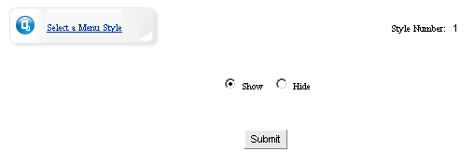
Click “Select menu style “, pop dialog box shown below: (you may select “hide “, edit menu by yourself)
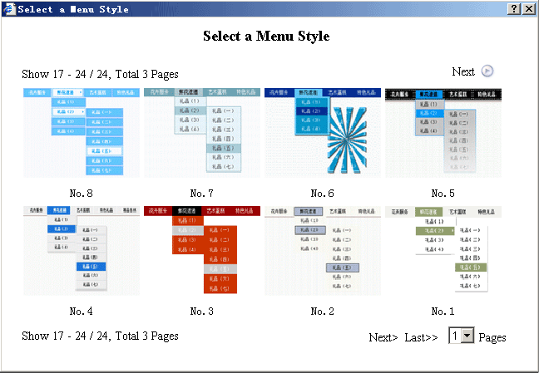
Select dynamic menu style which appropriate to templates, set “menu style “ successfully after click “submit “.

Item manager

Single page
Website management - Single page
“Single page“is the item which has only 1 webpage, commonly it is used to edit “About us“, “Contact“ etc. The management of single page use “HTML “which have powerful function.
Operation step:
- Build a”Single page “
Path: Manage menu in the left side of back “Website management “→“Add a new item “, the type of item is: “Single page “
- Edit single page
Path: Manage menu in the left side of back “Website management “→“Item manager “. page layout of back shown below:
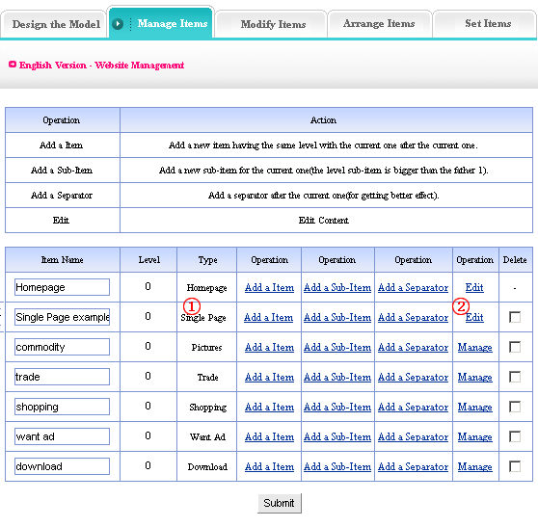
Click “edit “ (②)behind “single page “(①). The management of single page is to edit the unique webpage of the item, the following image shows:
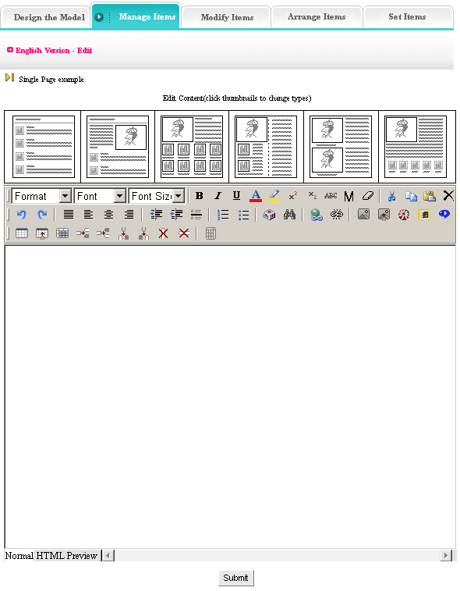
You may edit in the HTML according to your own habit.

Independent page
Website management - Independent page
“Independent page “, just as its name imply, it is the page independent from templates, complete user-defined.
Operation step:
1) Build a ”independent page“
Path: Manage menu in the left side of back “Website management “→“Add a new item “, select item type: “Independent page “.
2) Edit independent page
Path: Manage menu in the left side of back “Website management “→“Item manager “page layout of back shown below:
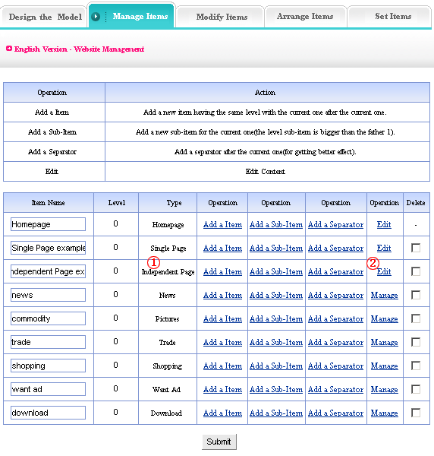
The content management of independent page is to edit the single webpage which different from other items, the following image shows: click “edit “ (②) behind “independent page “(①)
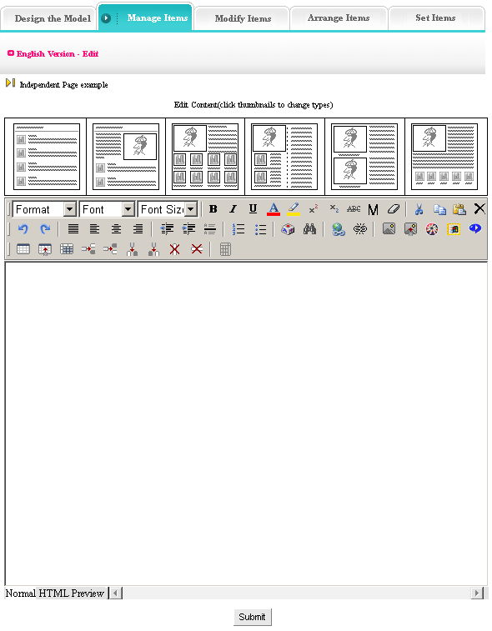
You may edit in HTML according to your own preference.

News
Website management - News
“News “is the item that system used to manage article, used in News, Article, Data, etc; build multilevels.
The management of “News“ include “Data manager“, “Category manager“, “Category transfer“ and “create code“.
Operation step:
- Build “News“ item
Path: Manager menu in the left side of back “Website management “→“Build a new item“, select item type: “News “
- Edit “News “item
Path: Manage menu in the left side of back “Website management“→“Item manager“ page layout of back shown below:
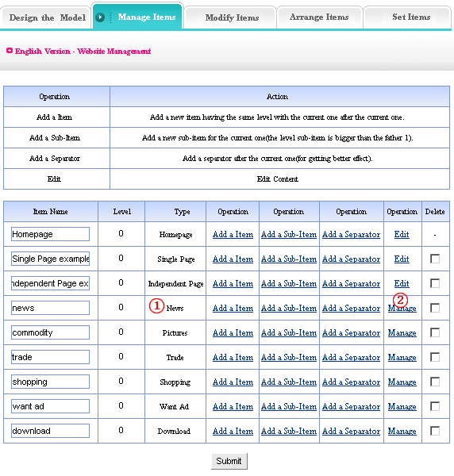
Enter into the back of operation: Click “manage “(②)behind “News “(①)the management page of News shown below:
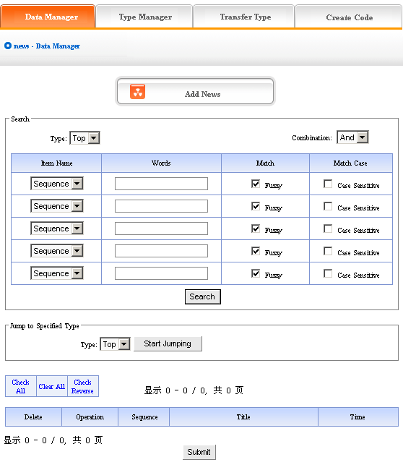
We will elaborate the four functions of “News “listed in image above:
1) Data manager: the function is used to manage the news of website. Mainly include add and delete the news. Click “Add news “button in the image above, enter into the page layout shown below:
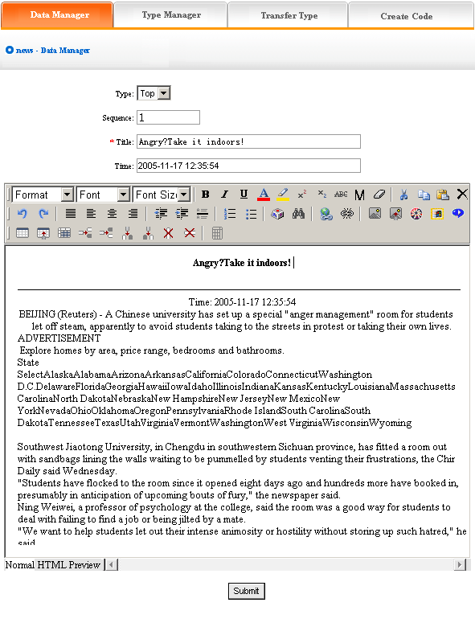
How to add news:
Type: first, be sure the type of news which you want to add (type: in order to convenient users, system classify different news, display different types in website. we will elaborate the classification methods below. You won’t set type if the news of website doesn’t need be classified).
Sequence: the news arranged in website as certain order (ascend, descend or self are all depend on sequence).
Title: the title of news displayed in website, the summarization of news content.
Publish time: it defaults the time you add news, you may input again if the date of news isn’t the time of adding news.
Edit the news content in the editing area below after set the above options, add news successfully after submit. The following image shows:
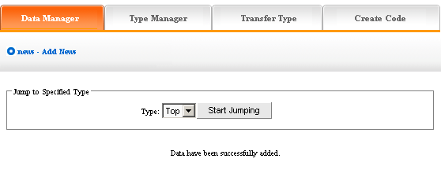
If need continue to add, click “Data manager “return to the upper lever of page, the operation is identical with above. The following image shows:
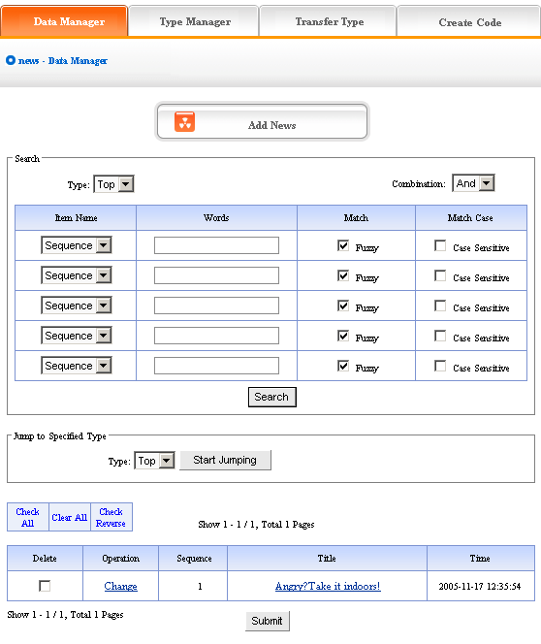
The news will display in the page after add.
Click “change“ in image above, enter into the editing page of news, set the news “title“, “publish time“, “sequence“ and “type“
You may check the news content by clicking the news title in the page shown above.
Pitch on “delete“, click “submit“, this news will be deleted.
2) Type manager:
Type: it is convenient for users to classify the content of news, if you don’t classify the content, all the content display together. After classified, the content is displayed as classified in website.
Operation: enter into the management back of “News“, click the “type manager“ in the upper of back
Enter into the page shown below:
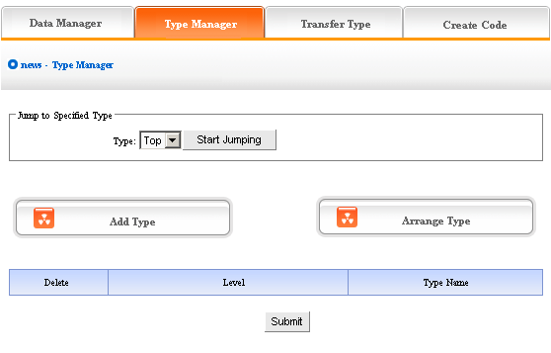
Add type: click the “Add type“ button in the image above, enter into the page shown below:
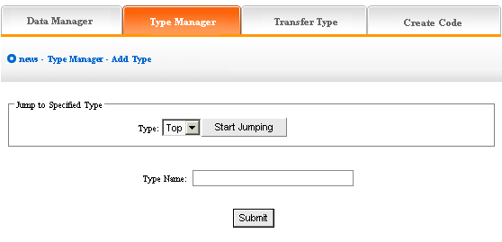
In the textbox of “type name“, input the type name you want to add, display “add type “successfully after submit!
If continue to add type, the method is identical with above. The following image shows: the type added just now displayed in the back, you may get a further classification in the type you just add, click the type you add in the drop-down list of type, start jumping, then click “Add type“ button, the original level is “0“, the level of new type is “1“, reason by analogy.
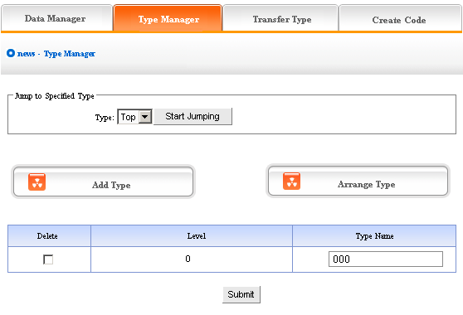
The image above shows: If you don’t need to reserve new type, pitch on “delete“, then click “submit“, the new type will be deleted.
Type level, the type level under top is 0, the type added after jumping to other type is lower than the original level (the original level is 0, the level added based it is 1)
Arrange type: click “Arrange type “button, enter into the following page shows:
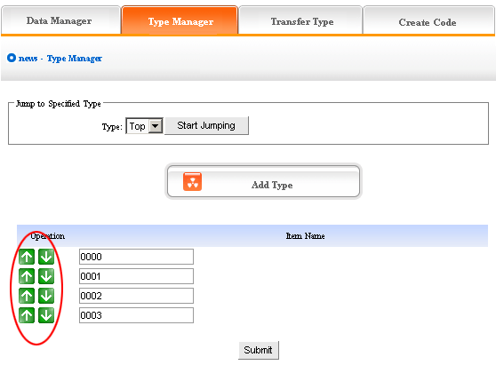
Click the arrow above to arrange type, submit after adjust, arrange type successfully.
The above “arrange type“ is in top, if arrange type in other types, you should jump to that type first, arrange subclass after jump successfully.
3) Type transfer: In the process of website designing, sometimes we need transfer the news of original type to the other types, so the function of “Transfer type“ is convenient for users.
Operation: enter into the back of “News“, click the “Transfer type“ in the upper of back“
Enter into the back as the following image shows:
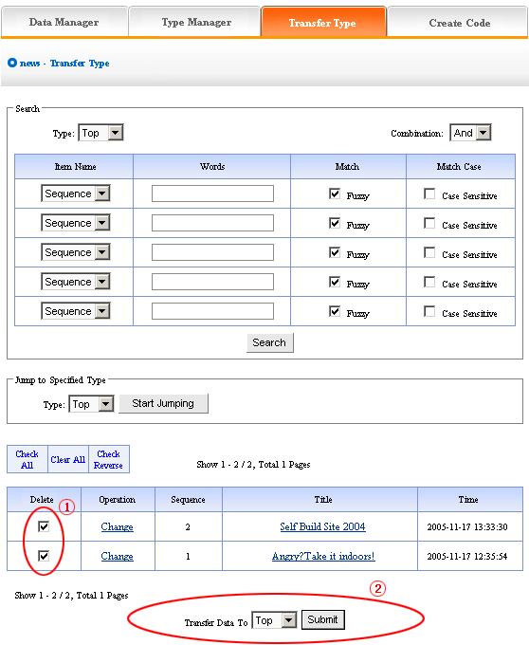
Open the type which need transferred, pitch on the news need transferred, the image above ① shows, in the drop-down list ② of image above, select the target option which news will transfer to, click “submit “, jump successfully (note: after jump successfully, news jump to the type pitched on from original type, the process is different from “copy “, but equal to “cut “operation)
4) Create code:
Create code: When we add news items of homepage or other page ( “Single page “/ “Independent page “), it is inefficient to add manually and get more trouble when update news. So we use “Create code “here, “Create code “create the news content of items which pitched on “dynamic code “, insert homepage or other webpage, when the back of this news item upgrade, the items(homepage/other page inserted create code)of news which insert create code upgrade along with it automatically.
Operation: enter into the back of “News “, click the “create code “in the upper of back stage
Enter into the following image shows:
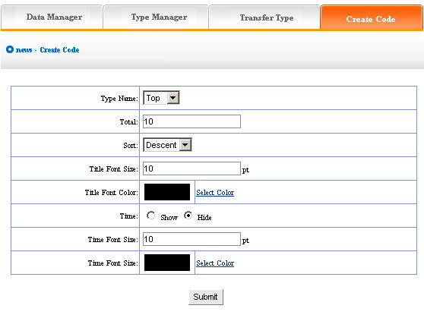
It is simple to use “Create code “, select some condition shown, press “submit “button, then create the code.
We elaborate the setting method of create code:
Type name: the item type which need create news code (select in the drop-down list)
Total: the news quantity displayed in homepage or other single page after create code. default 10, you may set according to designing situation of page which inserted code (if there are many news in the type, the system will sort according to the news sequence, then create the news quantity according to the sort which you select; if the news are less than the quantity you filled in, it will display all the news in the type)
Sort: the news sequence method of the page which need insert code after create code (according to the sequence number you set when add news)include “Ascend “, “Descend “, “Self “
Title font size/color: What “create code“ create is not entire chapter news, but the news title with hyperlink(enter into the paper of news content when clicking the title of news), the “font size/color “means the size of news title.
Time: What “create code“ create is not only the title of news, but also the time of publishing news, we may select whether display
Time font size/color: The same meaning and function with title font size and color.
After setting the above options, in the back, we enter into the following image shows:
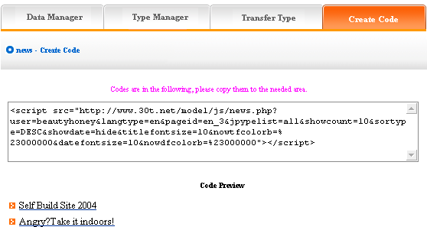
Copy the created code to the page which need to be inserted code.

Pictures
Website management - Pictures
“Pictures“ is the item which specialized in manage pictures, for example, products, certificates, outstanding achievement shows, etc; build multilevels.
The management of “Pictures “include “Data manager “, “Type manager “, “Transfer type “, “Create code“
Operation step:
- Build “Pictures “item
Path: Manage menu in the left side of back “Website management “→“Add newitem “, select item type is: “Pictures “
- Edit “Pictures “
Path: Manage menu in the left side of back “Website management “→“Item manager “
Enter into operation back: Click “management “behind “Website management “, the following image shows:
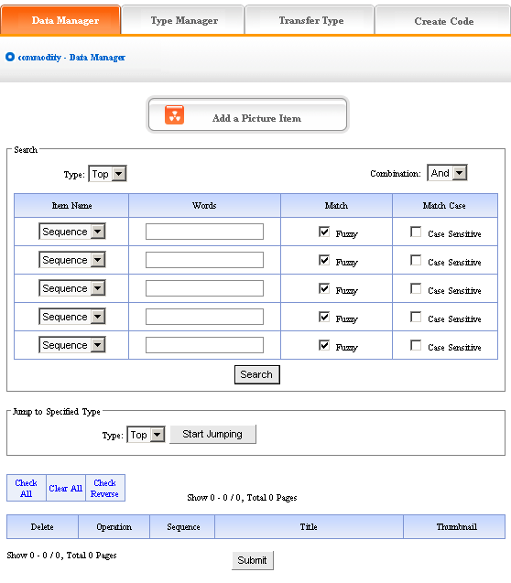
We elaborate the four functions of “News “:
1) Data manager: Manage the picture content of website. Mainly include adding and deleting the content of pictures. Click “Add a picture item “, enter into the following image:
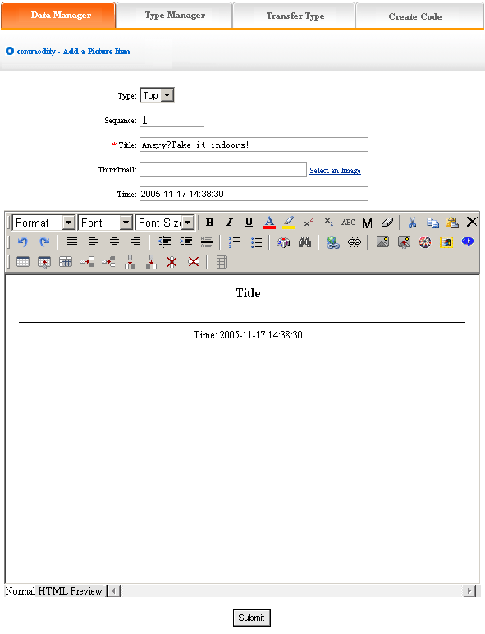
We elaborate how to add picture.
Type: Confirm which type the picture added belong to (if didn’t build type, it default top type)
Sequence: Make the pictures arranged as certain order in website (ascend, descend or self depend on sequence)
Title: the title of pictures displayed in website (differentiate picture information)
Time: default the time you add pictures, you may input here freely
Edit picture content in the editing area below after setting the options above, add picture successfully after submit. The following image shows:
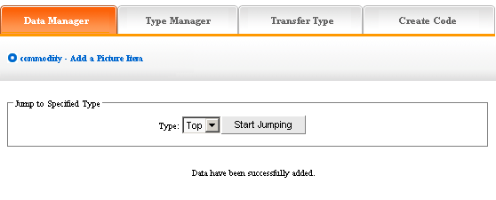
If you need to continue, click “data manager “return to the upper level, the step is identical with above. The following image shows:
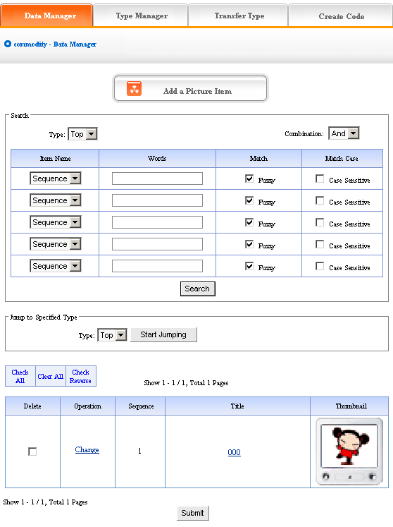
Pictures which add newly will display in the page after add pictures. The image above shows:
Click the “change “ of image above, enter into the editing page of pictures again, you may reset the “Title “, “Time “, “Sequence “and “Type “of pictures.
In the image above, you may check the content of pictures by clicking the title of pictures
Pitch on “delete “, click “submit “, the pictures will be deleted.
2) Type manager:
Type: Convenient for users to classify the content of pictures, if you don’t classify, all the pictures default top type; after classify, all the pictures displayed as classified in website
Operation: enter into the back of “Pictures “, click the “Type manager “of back. Back enter into the page shown below:
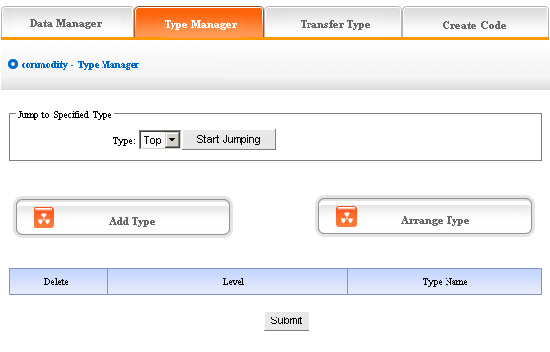
Add type: click “Add type “, enter into the page shown below:
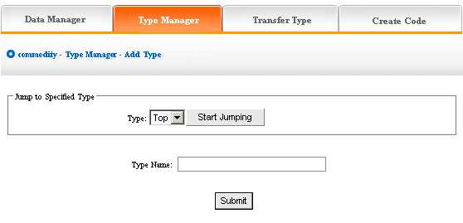
In the textbox of “type name “, input the name of type which you want to input, add type successfully after submit!
If you want to continue, the method is identical with above. The following image shows: the type added display in the back.
We can get a further classification of the type which we added, click the type which we just add in the drop-down list of sort, start jumping, then click “Add type “, the original level of type is 0, the new type based on the original one is 1, reason by analogy.
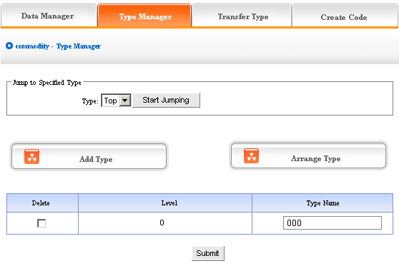
The image above shows: if you don’t want to keep new type, pitch on “delete “, click “submit “, the new type will be deleted.
Type level, the type level under the top is 0, the type which added by jumping to other types is lower than the original level(the original level is 0, the type level which added based on it is 1)
Arrange type: click “Arrange type “, enter into the page shown below:
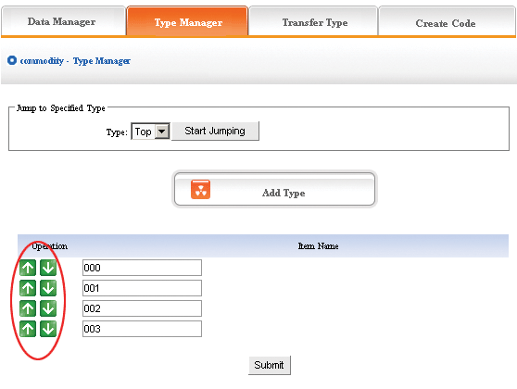
Adjust the position by clicking the arrow shown above, then submit, arrange type successfully.
The above “arrange type “is in top type, if you want to adjust the position of other types, you should jump to that type firstly, set the subclass after jumping successfully.
3) Transfer type: In the process of designing website, sometimes we need change the content of pictures in original type to the other types, so the functions of “Transfer type “can meet the needs.
Operation: enter into the back of “Pictures “, click the “Transfer type “in the upper of back
In the back, we enter into the following image shows:
Open the type which need to be transferred, pitch on the content of picture will be transferred, such as ①, in the drop-down list of ②, pitch on the type which the pictures will transfer to, click “submit “, jump successfully (note: after jumping successfully, the content of picture jump from the original type to the type which pitched on, the process is not “copy “, but equal to “cut “operation)
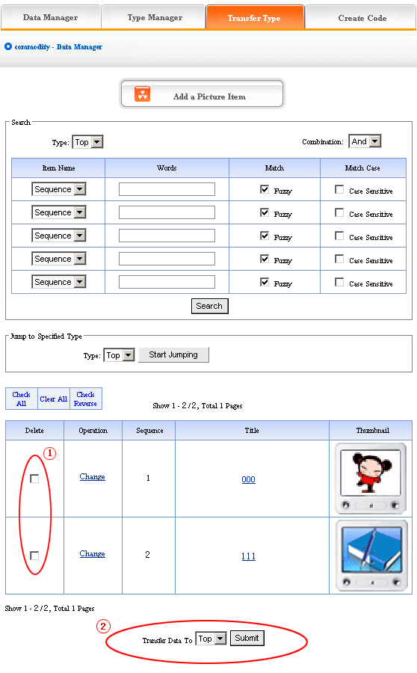
4) Create code:
Create code: When we add news items of homepage or other page (“Single page“ / “Independent page“), it is inefficient to add manually and get more trouble when update news. So we use “Create code “here, “Create code “create the pictures content of items which pitched on “dynamic code “, insert homepage or other webpage, when the back of this pictures item upgrade, the items(homepage/other page inserted create code)of pictures which insert create code upgrade along with it automatically.
Operation: enter into the back of “Pictures “, click the “create code “in the upper of back
In the back, we enter into the following page shows:
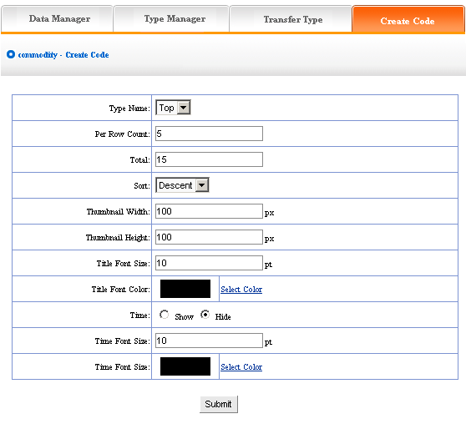
It is simple to use “Create code “, select some condition shown, press “submit “button, then create the code.
We elaborate the setting method of create code:
Type name: the item type which need create news code(select in the drop-down list)
Total: the news quantity displayed in homepage or other single page after create code. default is 10, you may set according to designing situation of page which inserted code(if there are many news in the type, the system will sort according to the news sequence, then create the news quantity according to the sort which you select; if the news are less than the quantity you filled in, it will display all the news in the type)
Sort: the news sequence method of the page which need insert code after create code(according to the sequence number you set when add news)include “Ascend “, “Descend “, “Self “
Title font size/color: What “create code “ create is not entire chapter news, but the news title with hyperlink(enter into the pape of news content when clicking the title of news), the “font size/color “means the size of news title.
Time: What “create code “ create is not only the title of news, but also the time of publishing news, we may select whether display
Time font size/color: The same meaning and function with title font size and color.
After setting the options above, in the back, we enter into the following image shows:
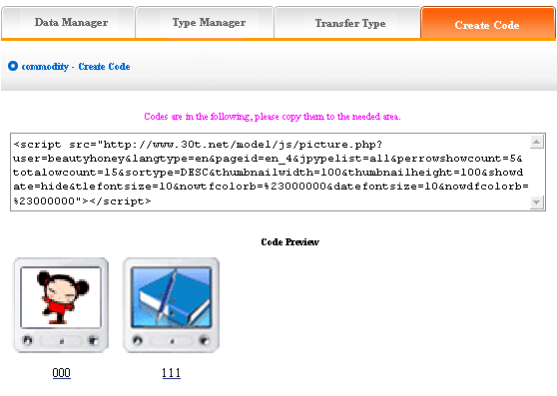
Copy the code to the page which needs to be inserted.

Feedback manager
Website management - Feedback manager
Feedback manager is used to building client’s feedback, order and enquiry, support, complain etc
“Feedback manager “include “Data manager “, “Set reason “, “Set type “, “Set item name and error information “
Operation:
- Build “Feedback “item
Path: Manage menu in the left side of back “Website management “→“Add newitem “, select the type of item: “Feedback “
- Edit “Feedback “
Path: Manage menu in the left side of back “Website management “→“Item manager “. the back shown below:
Enter into the back of operation: click “manage “behind “feedback “, the page of feedback showed below:
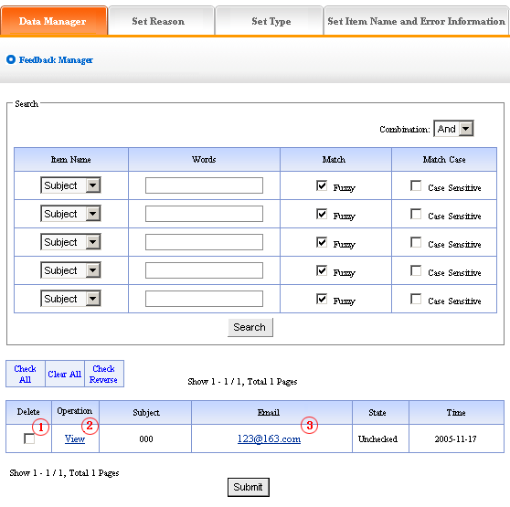
We elaborate the four functions of “Feedback “:
- Data manager: Manage the feedback submitted by the users
Operation: enter into the back of “Feedback “, click the “Data manager “in the upper of the back, enter into the following image shows
Delete: delete the message which users submitted, pitch on ① in the image above, click “submit “, the message will be deleted.
Check: click the “check “under ② in the image above, you may check the message left by users in the back
E-mail box: click the e-mail box ③in the image above, send e-mail to users directly.
- Set reason:
“Set reason “: it is the reason that users leave a message, system provide the function of classified message that convenient users. for example “website, on-line sale, sale and service of products “etc. the content we set here is the content displayed in the drop-down list when user leave a message, the following picture shows:
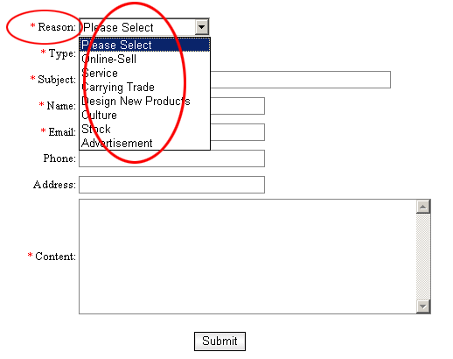
Operation: Enter into the back of “Feedback “, click the “Set reason “in the upper of back, and enter the page shown below:
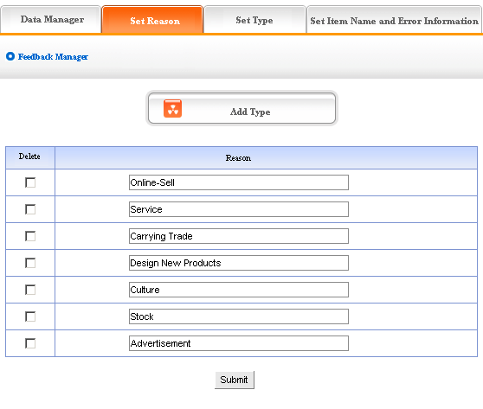
The above message type is system default; we may modify the reason given, and also add or delete the reason type. The operation is identical with “News “and “Pictures “. (for details please see page58－59)
3) Set type:
“Set type “means set the type which selected by users when leave a message, for example “consult, suggest, cooperate “etc. The content we set here is the options in the drop-down list when users leave a message, the following image shows:
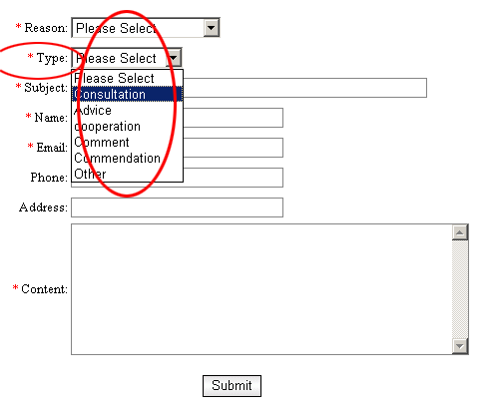
Operation: enter into the back of “Feedback “, click the “Set type “in the upper of back. enter the page shown below:
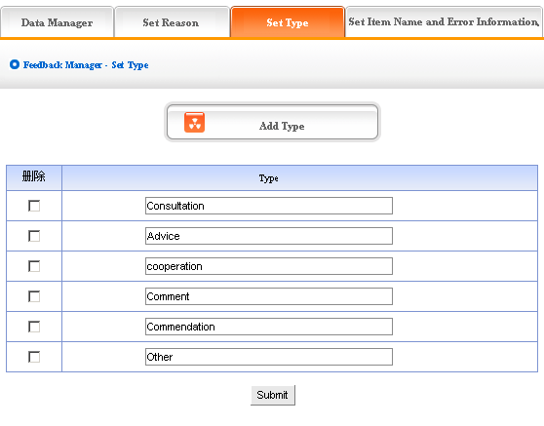
The above message type is system default; we may modify the reason given, and also add or delete the reason type. The operation is identical with “News “and “Pictures “. (for details please see page64－66)
4) Set the item name and error information
Item name: The content we set is the name we want to fill in the message board of front, such as “reason “, “type “, “title “, “name “, “e-mail “etc. the names of item displayed in website shown below:
Error information: it is the pop hint when the information the users filled in is not corresponding with request, for example, the users submit it but didn’t select the “reason “, the system will pop information “please select reason! “; if the users submit it but didn’t fill in the “subject “, the system will pop information “please input subject!(within 300 characters) “
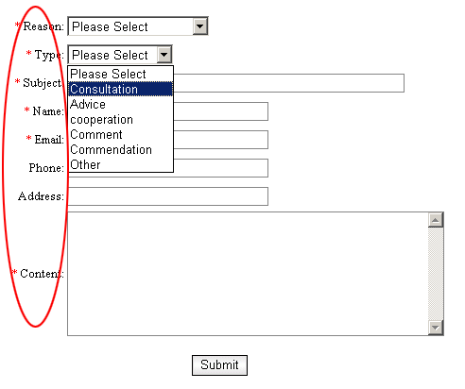
Operation: enter into the back of “Feedback “, click the “set item name and error information “in the upper of back, enter into the page shown below:
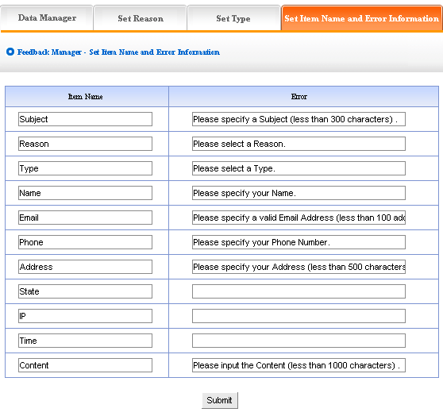
The image above shows: the content of “item name“ and “error information“ may be modified according to actual circumstance, we may also add type of information. The concrete operation is identical with “News“, “Picture“ (for details please see page64－66)

Guestbook manager
Website management - Guestbook manager
Guestbook manager: it means manage the message board of the website(the difference from the “feedback“ is that the content of “Guestbook “should check in the back, but the content of “Guestbook“ is public in web)
The management of “Guestbook “include “Data manager“, “Set item name and error information“
Operation:
- Build “Guestbook “item
Path: Manage menu in the left side of back “Website management“→“Add new item“, the select type of item: “Guestbook “
- Edit “Guestbook “
Path: Manage menu in the left side of back “Website management“→ “Item manager“the back shown below:
Enter into the back of operation: click “manage“ behind “Guestbook“. The content of guestbook shown below:
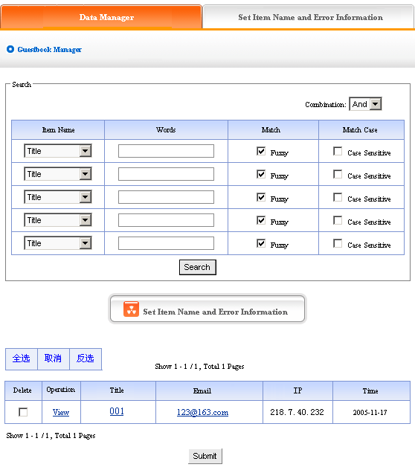
We elaborate the two management functions of “Guestbook “according to the image above:
- Data manager: Manage the message that users submit in the front.
Operation: enter into the back of “Guestbook “, click the “data manager “in the upper of back. enter into the page shown above:
Delete: delete the message which users submit, pitch on ① in the image above, click “submit “, the message will be deleted.
Check: click “check “under ② in the image above, we can check the message which users leave in the back.
Email: click email ③ in the image above, send email to users directly
- Set item name and error information:
The meaning of “item name “and “error information “is identical with the “feedback “, in the message board of the front, means pop hint when users submit the message and fill in the item name that aren’t corresponding with the request.
Operation: enter into the back of “Guestbook “, click the “set item name and error information “in the upper of back. The following image shows:
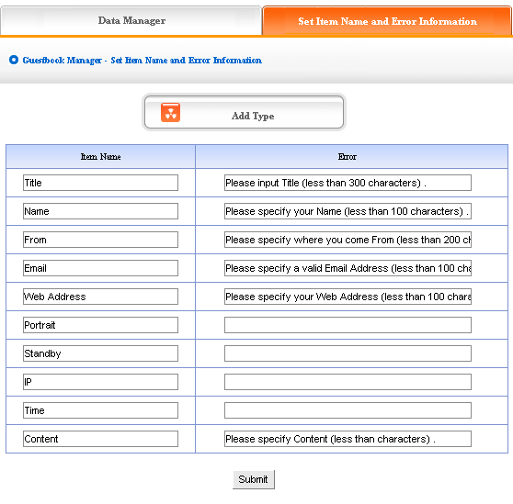
The image above shows: the content of “item name“ and “error information“ may be modified according to the actual circumstance, we may also add type of information here. The concrete of operation is identical with “News“, “Pictures“ (for details please see page64－66)

Trade
Website management - Trade
Trade: the item is system provide for convenient supply and demand
The management of “Trade “include“ data manager“, “type manager“, “transfer type“, “create code“
Operation:
- Build “Trade“ item
Path: Manage menu in the left side of back “Website management“→ “Add new item“, the select type of item: “Trade“
- Edit “Trade“
Path: Manage menu in the left side of back “Website management“→“Item manger“ the back shown below:
Enter into the back of operation: click “manage“ behind “Item manager“, the page of “Trade“ shown below:
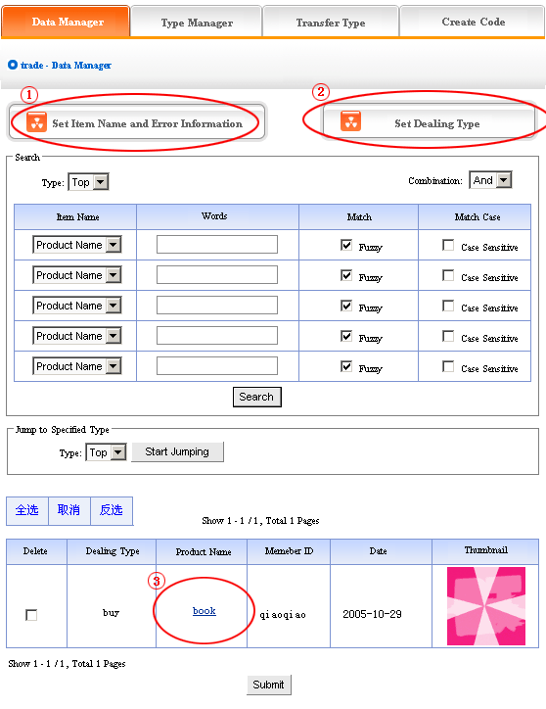
1) Data manager: let’s get to know the function of “Data manager “according to the “Trade manager “in image above.
Click ① “Set item name and error information “in image above, in the back, we enter into the page shown below:
The meaning of “item name “and “error information “here is identical with “feedback “, “guestbook “, it means pop hint when users fill in item name and submit occurring a mistake.
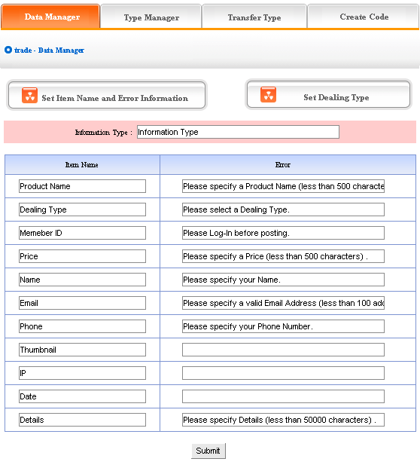
The image above shows: the content of “item name“ and “error information“ may be changed according to actual circumstance, you may also add type of information. The concrete operation is identical with “News“, “Pictures“, for details see page64－66.
Click “data manager “② “Set trade “, in the back, we enter into the page shown below:
“Set trade type “means the trading type selected by users when publish supply/demand information, for example “purchase, sale, rent“, etc.
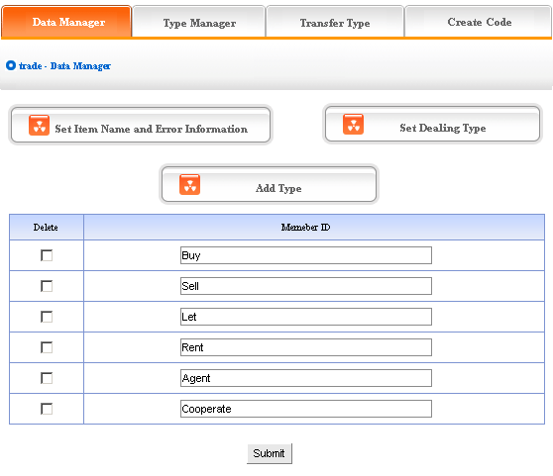
The above message type is system default; we may modify the reason given and also add or delete reason type. the operation is identical with “News“ and “Pictures (for details see page64－66).
Click commodity name③ of “data manager “in back, we may check the detailed information of commodity, the following image shows:
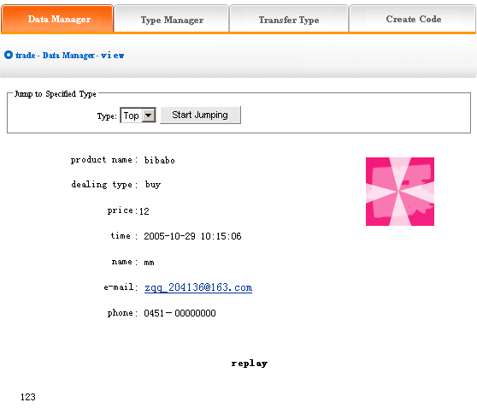
Click “email “here send email to users directly.
2) Type manager: It is convenient for users to classify different content of trade information. Users may lookup the type in need directly, operate conveniently, audio-visual effect.
Operation: enter into the back of “Trade “, click “type manager “in the upper of back
The backstage shown below:
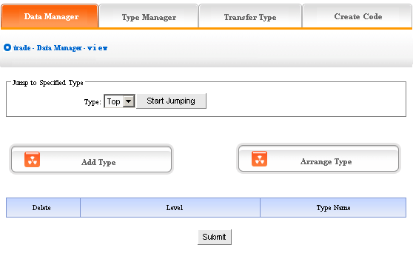
We can set “Add type “, “Delete type “and “Arrange type “here, the operation method is identical with “News “. for details please see page64－66
③ Transfer type: In the process of web designing, sometimes we need transfer the trade information in original type to the other types, so the function of “Type transfer “can meet the needs.
Operation: enter into the back of “Trade “, click “Transfer type “in the upper of back, we enter into the page shown below:
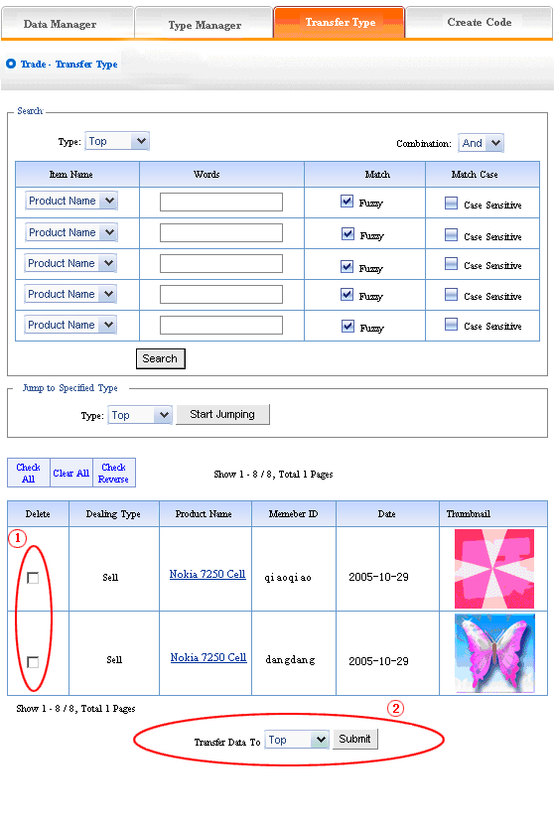
Open the type which need to be transferred, pitch on the content of picture will be transferred, such as ①, in the drop-down list of ②, pitch on the type which the pictures will transfer to, click “submit “, jump successfully (note: after jumping successfully, the content of picture jump from the original type to the type which pitched on, the process is not “copy “, but equal to “cut “operation)
④ Create code:
Create code: When we add news items of homepage or other page ( “Single page “/ “Independent page “), it is inefficient to add manually and get more trouble when update news. So we use “Create code “here, “Create code “create the trade content of items which pitched on “dynamic code “, insert homepage or other webpage, when the back of this trade item upgrade, the items(homepage/other page inserted create code)of trade which insert create code upgrade along with it automatically.
Operation: Enter into the back of “Trade “, click “Create code “in the upper of back “
In the back, we enter into the following image shows:
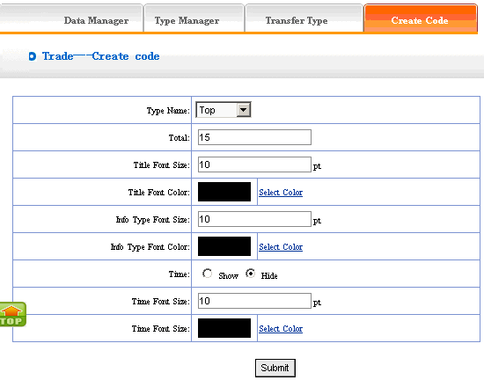
It is simple to use “Create code “, select some condition shown, press “submit “button, then create the code. the setting is the same with “News “, for details please see page68(type name: the item type which need to create the code of trade, select in the drop-down list. type font size/color: the type is the “trading type “which we set originally to display. , such as “purchase “, “sale “, “rent “etc.
Finish the above options, we enter into the page shown below after submit:
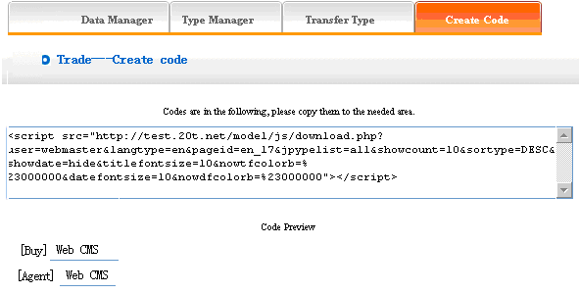
Copy the code to the page which need to be inserted

Want ad
Website management - Want ad
“Want ad “is used in recruiting column, submit application on-line.
The management of “Want ad “include “data manager“, “add want ad“, “person manager“, “set item name and error information“
Operation:
- Build “Want ad“
Path: Manage menu in the left side of back “Website management“→ “Add new item“, the selected type of item: “Want ad“
- Edit “Want ad “
Path: Manage menu in the left side of back “Website management“→ “Item manager“ the page of back shown below:
Enter into the back of operation: click “manage“ behind “Want ad“, the page of “Want ad“ shown below:
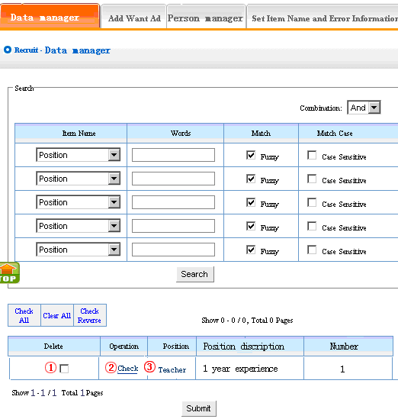
1) Data manager: Manage the want ad. Let’s get to know the function of “data manager“ according to “Want ad“ page shown in image above.
①: Delete the want ad
②: Modify the want ad. After click, we get into the page shown below:
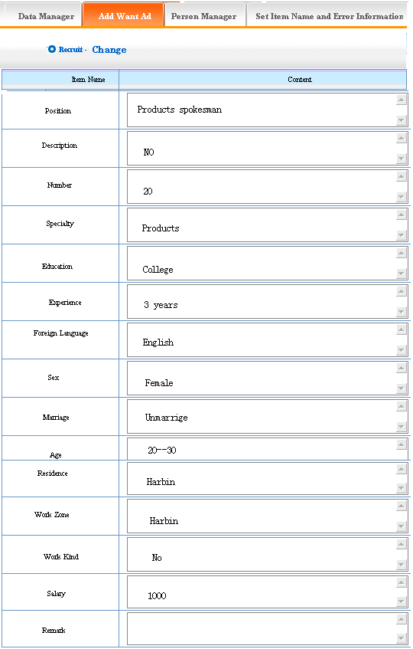
Click “data manager “③: enter into the page shown below, we may check the want ad.
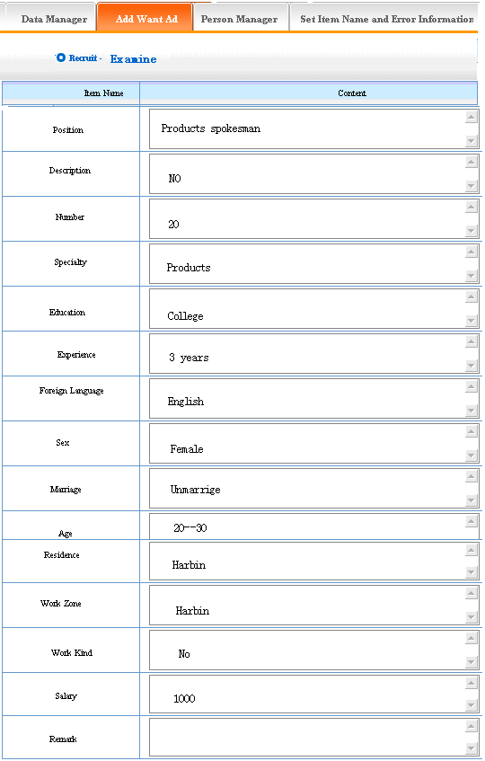
2) Add want ad: the content we set is the want ad of your company displayed in website, we may add want ad according to the talent management of your company.
Operation: enter into the back of “Want ad“, click the “add want ad“ in the upper of back. We enter into the page shown below:
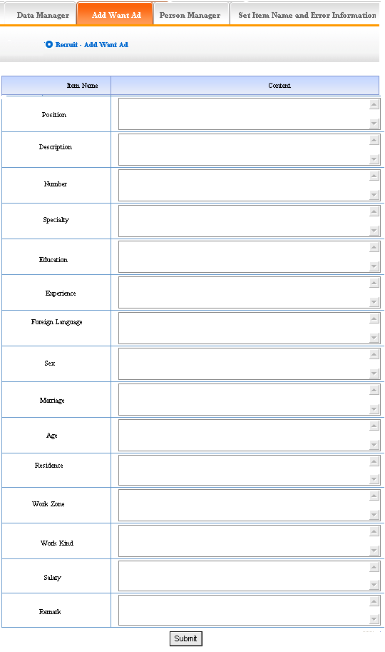
The info option which need users fill in has given, fill the request in the text field. The want ad which we add will display in the website.
- Person manager: It is the function that manages the applying information. You may check /delete the information of applicant or send email to applicant
Operation: Enter into the back of “Want ad “, click the “Person manager “in the upper of back and enter into the back shown below:
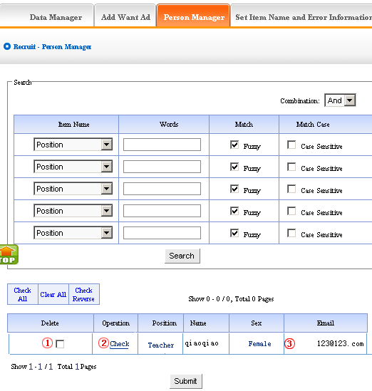
It includes three aspects of managing the information of applicant:
Delete the information, operation: click ①in the image above
Check the information, operation: click②
Send email to applicant, operation: click ③
- Set item name and error information:
Operation: enter into the back of “Want ad “, click the “Set item name and error information “in the upper of the back, in the back, we enter into the following image shows:
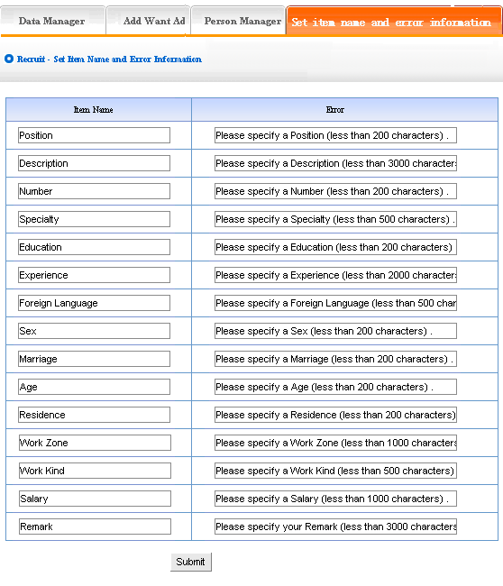
Item name: it is the item name which need applicant filled in the front. The following image shows:
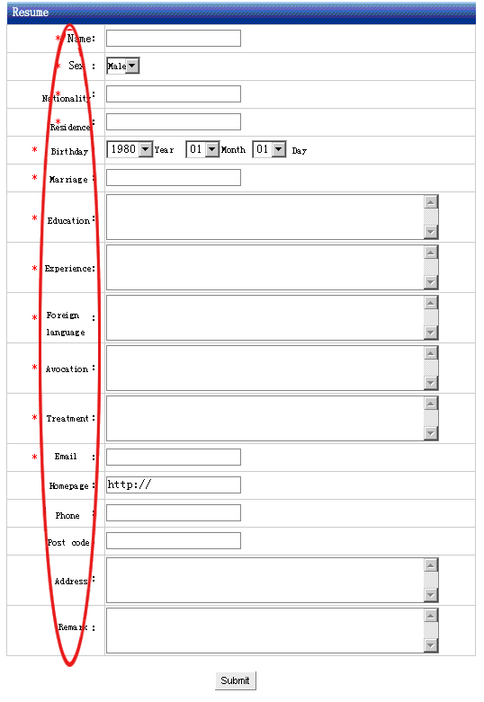
“Set item name and error information “: It means pop hint when applying information submitted by users isn’t corresponding with request. Some hint is default; you may change it according to your company actual circumstance

Download
Website management - Download
“Download “may build a item for online download, for example software, download files
The management of “Download “include “type manager “, “data manager “, “add files “, “create code “
Operation:
- Build “Download “item
Path: the “website management “in the left side of back”→ “Add new item “, select the item type: “Download files “
- Edit “Download “
Path: the “website management “in the left side of back” → “Item manager “. the back shown below:
Enter into the back of operation: click “manage “behind “Download “, the page of download shown below:
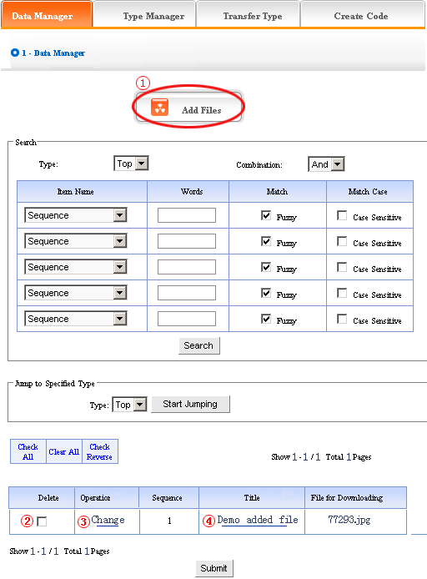
1) Data manager: It means the management of want ad. Let’s get to know the function of “data manger “first according to the page of “Want ad“ in the image above.
①: Add files (add the files which can be downloaded in the front)
Operation: click ① “Add files“, enter into the back shown below:
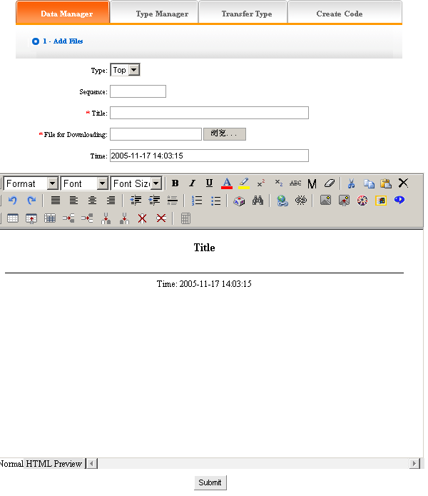
We will elaborate how to add files:
Type: make sure the files will be added which type belong to (if did not build type, default top type)
Sequence: Make sure the files arranged as certain order in website (ascend, descend or self are all according to sequence)
Title: The title of files shown in website(also can differentiate files information)
Files for downloading: it means the files added which can be downloaded in website, click “scan “. You may also input the address of files directly if you have known the files path
Time: the item default the time when add files, you may input here freely
You may edit the content of files after set the options above in the image below. The following image shows the page added successfully:
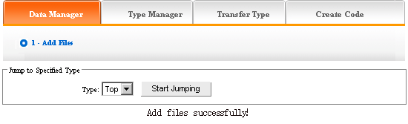
If you need to continue, back to the page “Data manager “, repeat the operation above.
Click ② in the image above, pitch on “delete “, click “submit “, the files will be deleted.
Click ③ “change “, enter into “add files “again, you may set “title “, “time “, “sequence “and “type “of files newly.
Click the title of ④ in the image above, you may check the instruction of the file
2)Type manager: you may classify the files here, all the files defaulted top type if you don’t classify; after that, all the files displayed as classified.
Operation: enter into the back of “Download “, click “type manager “in the upper of back. we enter into the following image shows:
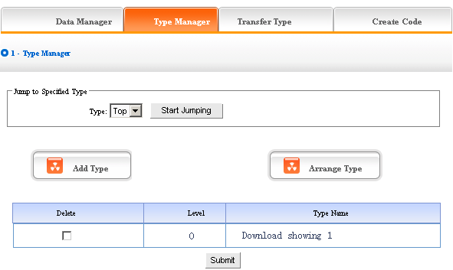
We may also set “add type“ and “arrange type“, the concrete operation is identical with “News“and “Picture“(for details please see page64－66)
3) Transfer type: in the process of designing website, sometimes we need transfer the files from original type to the other types, the function of “transfer type “can meet the needs
Operation: enter into the back of “download “, click the “transfer type “in the upper of back
The following image shows:
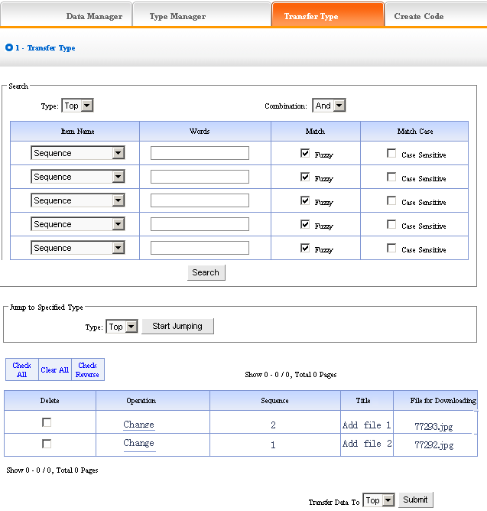
Open the type which need to be transferred, pitch on the content of picture will be transferred, such as ①, in the drop-down list of ②, pitch on the type which the pictures will transfer to, click “submit “, jump successfully (note: after jumping successfully, the content of picture jump from the original type to the type which pitched on, the process is not “copy “, but equal to “cut “operation)
4) Create code:
Create code: When we add news items of homepage or other page ( “Single page “/ “Independent page “), it is inefficient to add manually and get more trouble when update news. So we use “Create code “here, “Create code “create the “download “ content which pitched on “dynamic code “, insert homepage or other webpage, when the back of this “download “ upgrade, the items(homepage/other page inserted create code)of “download “ which insert create code upgrade along with it automatically.
Operation: enter into the back of “Download “, click “create code “in the upper of back
The following image shows:
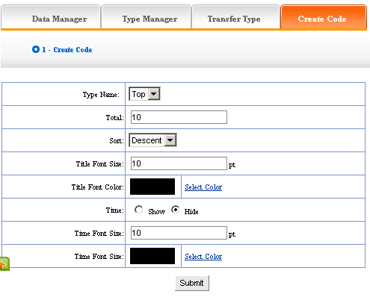
It is simple to use “Create code “, select some condition shown, press “submit “button, then create the code. Here, the setting method is identical with “News “, for details please see page68
After setting the options above, the back shown below after submit:
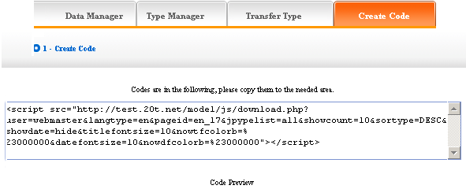
Copy the code to the page which needs to be inserted.

Shopping
Website management - Shopping
The item of “Shopping “include member register, score, product sort, product manager, add product, payment, delivery, order manager, create code, etc.
- Build the item of “Shopping “
Path: the manage menu in the left side of back “Website management “→ “Add new item “, the item type selected: “Shopping “
- Edit “Shopping “
Path: manage menu in the left side of back “Website management “→ “Item manager “click “Manage “behind “Shopping “, the page shown below:
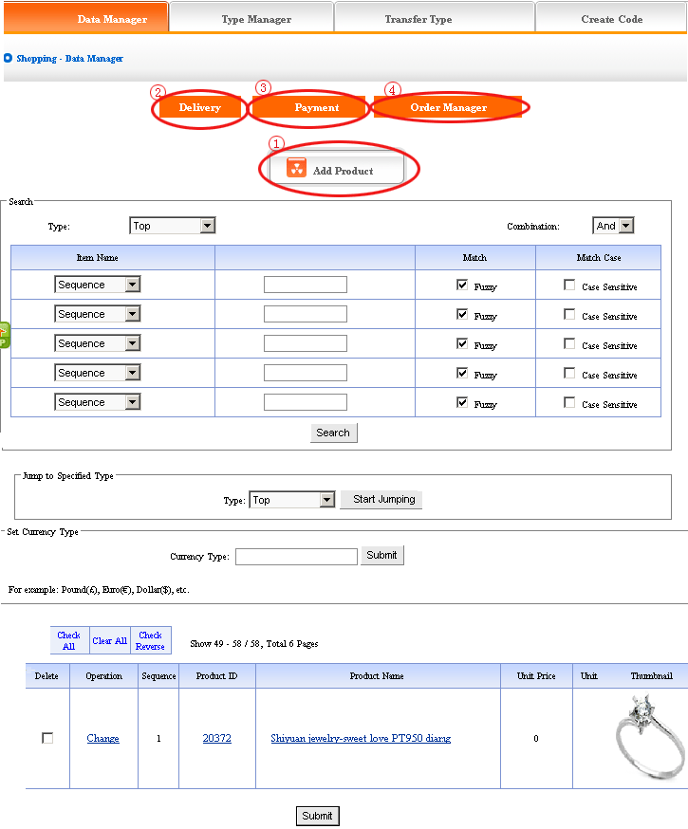
1) Data manager: Let’s get to know the content of “data manager “in the item of “shopping “according to the image above:
Click ① “Add products “, enter into the page shown below: you may add the products seen in front
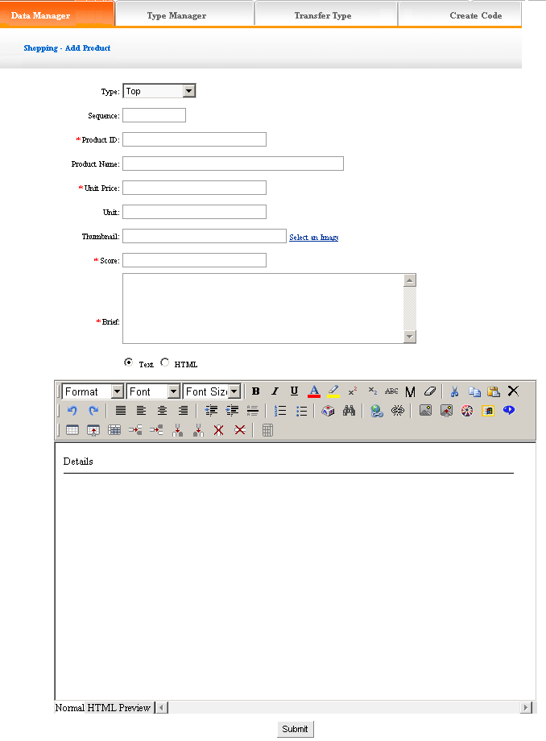
The content we fill in is the information displayed in front, fill content in the corresponding position in the image above. The score is used to evaluate the level of members. Edit the instruction of products in the editor.
Delivery: The content is the method of delivering goods when buying products.
Click “delivery“ ② in “Data manager“, in the back, we enter into the page shown below:
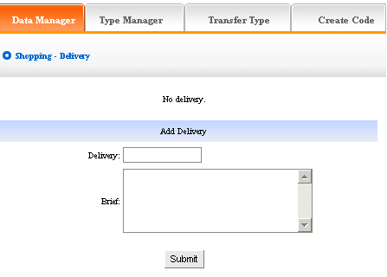
Payment: the payment method of shopping
Click ③ “payment “in “data manager “, the following image shows:
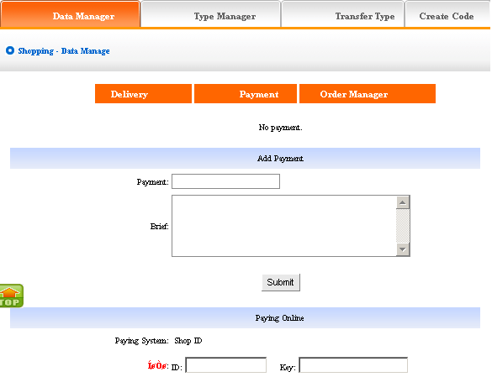
We may add “payment “of shopping.
Payment on-line: The content is shop ID which your company applies in “on-line “bank, your user may pay according to the address.
Order manager: Manage the order filled by members when buying products
Click “Order manager“ ④ in “Data manager“, the following image. Shows:
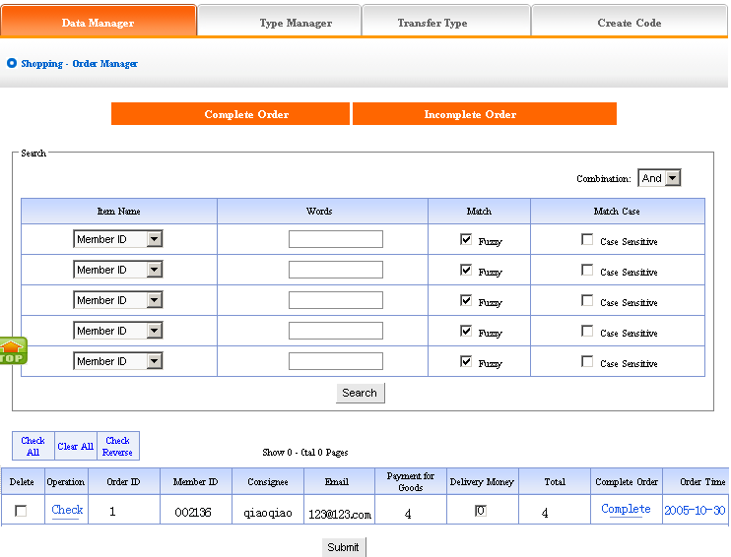
We may delete/check orders in the page shown above. “Complete order“ means the orders which have delivered goods, “incomplete order“ means that have not delivered, click “complete“ switch “incomplete order“ to “complete order“, in the page of “Complete order“ , click “return“, switch “complete order“ to “incomplete order“.
2)Type manager: You may classify the products, all the products default displayed in top type if you don’t classify the products; after classify, all the products displayed as classified in website.
Operation: enter into the back of “Shopping“, click the “type manager“ in the upper of back. The following image shows:
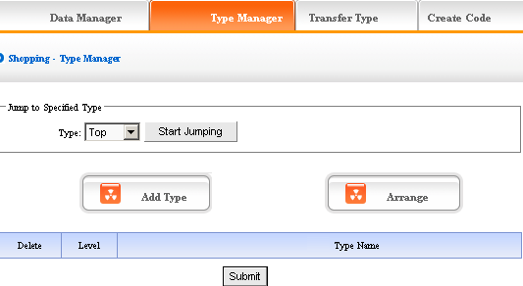
We may set “Add type“, “Delete type“ and “Arrange type“ here, the concrete operation is identical with “News“ and “Pictures“ (For details please see page64－66).
3) Transfer type: in the process of designing website, sometimes we need transfer the content of shopping in original type to the other types, the function of “Transfer type “can meet the needs.
Operation: Enter into the back of “shopping “, click “Transfer type “in the upper of back.
The following image shows:
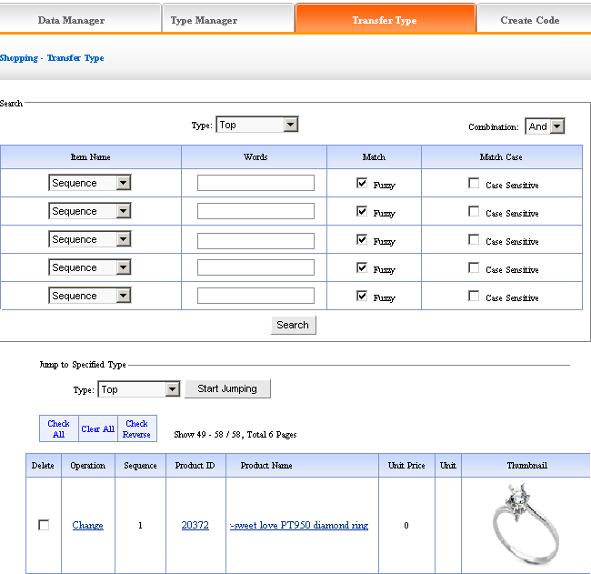
Open the type which need to be transferred, pitch on the content of picture will be transferred, such as ①, in the drop-down list of ②, pitch on the type which the pictures will transfer to, click “submit “, jump successfully (note: after jumping successfully, the content of picture jump from the original type to the type which pitched on, the process is not “copy “, but equal to “cut “operation).
4) Create code:
Create code: When we add news items of homepage or other page ( “Single page “/ “Independent page “), it is inefficient to add manually and get more trouble when update news. So we use “Create code “here, “Create code “create the shopping content which pitched on “dynamic code “, insert homepage or other webpage, when the back of this shopping upgrade, the items(homepage/other page inserted create code)of news which insert create code upgrade along with it automatically.
Operation: Enter into the back of “Shopping“, click “create code “in the upper of back“.
The following image shows:
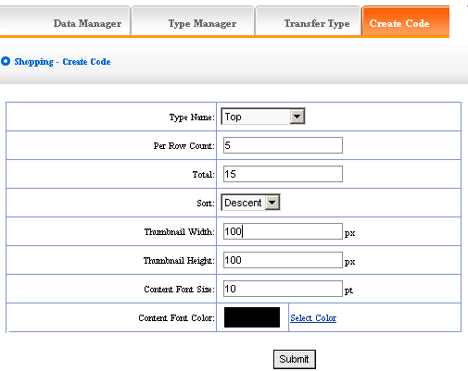
It is simple to use “Create code “, select some condition shown, press “submit“ button, then create the code. The setting method is the same with “News“, for details see page 68 (thumbnail width/height: means the size of thumbnail which displayed in front by the code; Content font/color: The character size/color of the products introduction).
After setting the options above, we enter into the page shown below after submit:
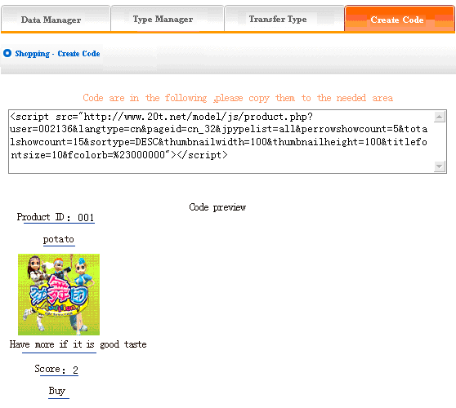
Copy the code to the page which needs to be inserted.

Self form
Website management - Self form
It is the item which designed by yourself, such as investigate, feedback, etc.
The management of “Self form “include “Data manager“, “Set item name and error information“.
Operation:
- Build “Self form“
Path: Manage menu in the left side of backstage “Website management“→ “Add new item“, select the type: “Download“.
- Edit “Self form“
- Data manager:
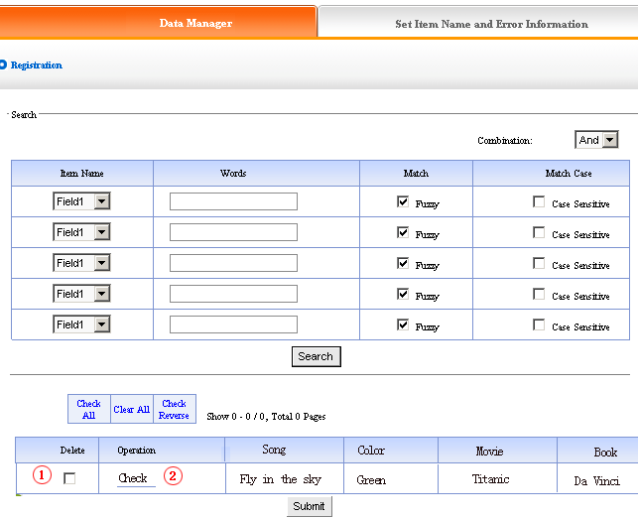
We may “delete“ and “check“ the information submitted by users.
- Set item name and error information:
Item name: The item name displayed in front which needs users fill in.
Set item name and error information: pop hint when the information submitted in front is not corresponding with request. You should set it according to the actual circumstance of item type.
Operation: Enter into the back of “Self form “, click “Set item name and error information in the upper of back, the following image shows:
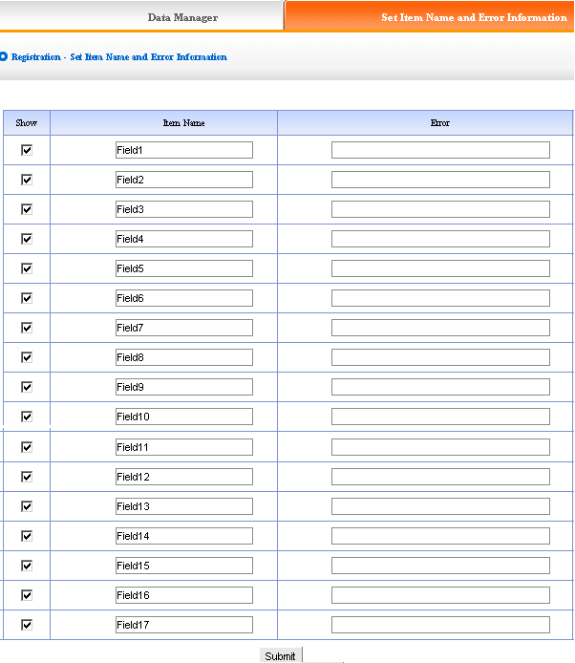
“Item name “default from “field1 “to “field30 “, we input the item name which will be displayed in front.
Input content in “error “which match with the fields (when input item name and error information, it will display in front which pitched on “show “, otherwise it will hide).

Introduction of on-line HTML
Let’s elaborate the function of tool bar in HTML:
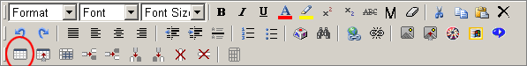
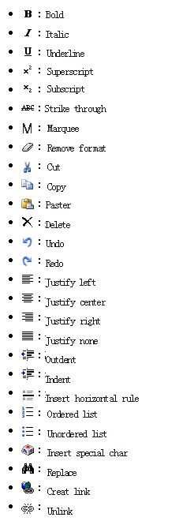
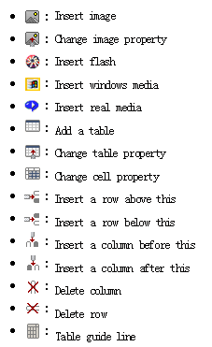

Add a table
Click “ “icon
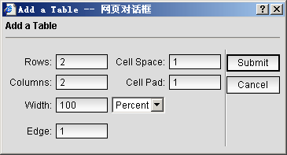
Rows: input the rows you need
Columns: input the columns you need
Width: choose the unit percent or pixel
Edge: the pixel width of edge
Cell space: it is used to define the filling space of table. it means the space between inner-edge and content.
Cell pad: it is used to define the space of table. it means the separate width between tables
Change the table property:
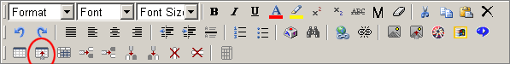
Click “ “icon
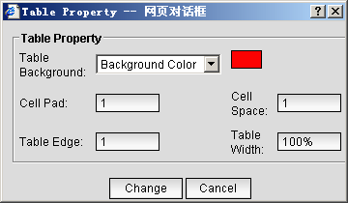
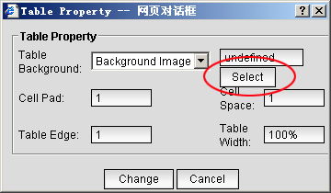

Insert image
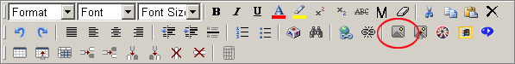
Click “ “icon, select upload image, press “upload “button.

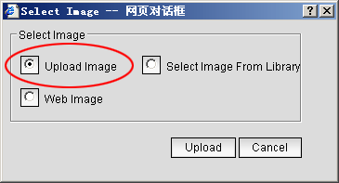
Click “scan “select the image need uploaded
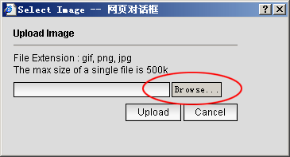
Select image from library, press “select “button.
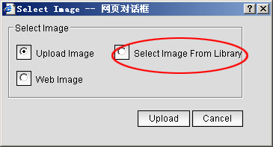
Select image from library.
Select web image, press “input “button.
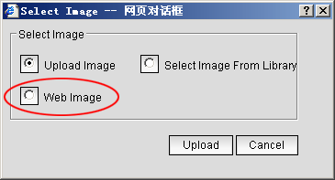
Fill in the URL of the image, click “submit “.
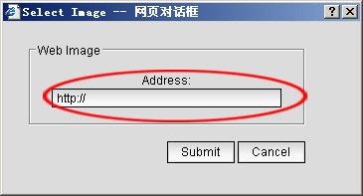

Insert flash
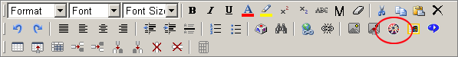
Click “ “icon.
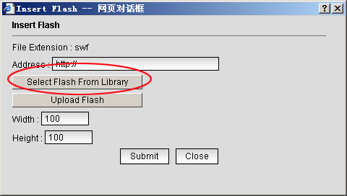
Click “select Flash from library “.
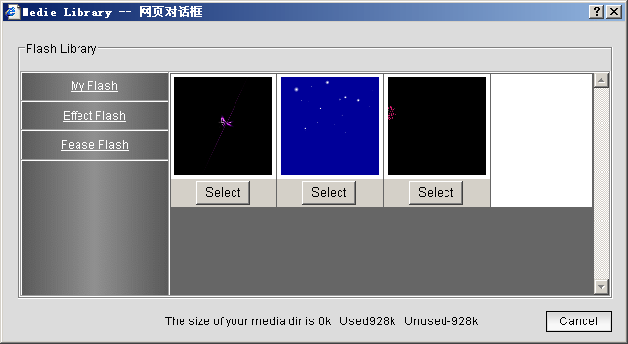
Click “upload Flash “.
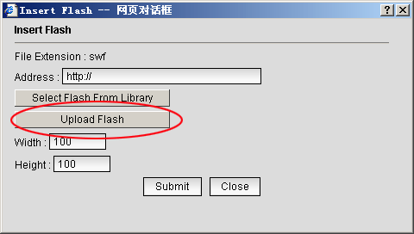
Click “scan “select Flash which need upload.
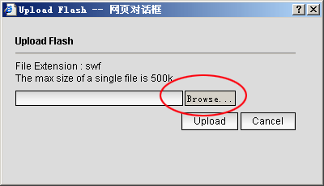

Insert windows/real media.
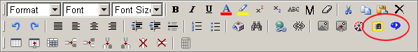
Click “ “icon, you may insert avi, wmv, mov.
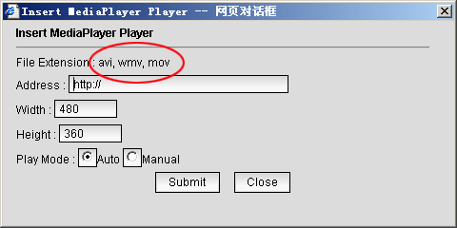
Click “ “icon, you may insert rm, ra, ram.
